Annex 2 to the Informative Report “On Latvia’s FinTech Sector Development Strategy”. Latvia’s FinTech Ecosystem and Summary of the Assessment on Access to Payment Infrastructure.
Contents
1 Assessment of the State of the Latvian FinTech Ecosystem 4
1.1 Technological scope 4
1.2 Technologies having a significant impact on development of the FinTech sector 5
1.2.1 Cognitive technologies and artificial intelligence 5
1.2.2 DLT, blockchains 6
1.2.3 Big data and analysis 6
1.2.4 Automation 7
1.2.5 Cloud computing 7
1.3 The structure of Latvia’s FinTech market 8
1.4 Sectoral analysis 11
1.4.1 Payment and e-money institutions 11
1.4.2 Crowdfunding platforms and investment platforms (investment service providers) 12
1.4.3 Private lending 14
1.4.4 Crypto-assets service providers 16
1.4.5 RegTech and IT sector participants 17
1.5 Assessment of Latvia’s FinTech ecosystem 18
1.5.1 Regulatory assessment 19
1.6 Support mechanisms 22
1.6.1 Innovation Hub 22
1.6.2 Regulatory Sandbox 23
1.6.3 Open cooperation or open banking 24
1.6.4 Other auxiliary tools 25
1.7 The impact of digitisation of the economy 27
1.8 Capital accessibility 28
1.9 Country image and communication 32
1.10 Education and talent base 32
1.11 Barriers to development of financial innovation 35
1.11.1 Access to payment infrastructure 35
1.11.2 Resource constraints 36
1.11.3 Licensing process and requirements 36
1.11.4 State aid for FinTech companies and capital accessibility in the financial sector 36
1.11.5 Talent base and access to human resources 37
1.12 Technology and infrastructure 37
1.12.1 Application of technology in the financial sector in Latvia 37
1.12.2 RegTech and SupTech development - technologies used in the supervisory work 39
1.13 Assessment of the possibilities of PI/EMI to open a current account 40
1.13.1 General information 40
1.13.2 Summary and possible solutions 42
1.14 SWOT analysis 42
1.15 Risks 44

Abbreviations
DeFI | Decentralised finance
DLT | The term is being used to denote distributed ledger technology
MoE | Ministry of Economics
EMI | Electronic money institutions
EU | European Union
FinTech | Financial technologies
FCMC | Financial and Capital Market Commission
MoF | Ministry of Finance
IF | Investment firm
MoI | Ministry of the Interior
ICT | Information and communication technologies
LABA | Latvian Insurance Brokers Association
LAFPA | Alternative Financial Services Association of Latvia
LB | Latvijas Banka (Bank of Latvia)
FLA | Finance Latvia Association
LIAA | Investment and Development Agency of Latvia
LIKTA | Latvian Information and Communication Technologies Association
LMENA | Association of Latvian Payment and Electronic Money Service Providers
LPABA | Latvian Professional Insurance Brokers Association
LU | University of Latvia
PI | Payment institutions
AI | Artificial intelligence
SMEs | Small and Medium Enterprises
ANFSP | Association of Nonbank Financial Service Providers
AML/CTPF | Anti-money laundering and combating terrorism and proliferation financing
OCMA | Office of Citizenship and Migration Affairs
CRPC | Consumer Rights Protection Centre
RPA | Robotised Process Automation
MEPRD | Ministry of Environmental Protection and Regional Development
SRS | State Revenue Service

Assessment of the State of the Latvian FinTech Ecosystem
(as of Q2 2021)

Technological scope
The global technology development path reflects the impact of technologies on financial services and also demonstrates an impact in FinTech companies. The economy has successfully moved from Industry 3.0 to the first steps of Industry 4.0, by introducing technologies such as blockchain, application programming interface (API), artificial intelligence, machine learning, automated assistants, big data, etc. This in turn has stimulated the development of new business models, for example, in the field of crowdfunding, payment services and lending, comprising the sector of financial technology companies (hereinafter also - FinTech , regulatory technology companies (hereinafter also - RegTech) and insurance technology companies (hereinafter also - InsurTech).
18-19th century
Industry 1.0
Mechanisation, Urbanisation, Steam power
1870-1914
1980
now
Industry 2.0
Mass production, conveyor, assembly lines, transport transformation

Industry 3.0
Digital revolution, programming, automation, internet banking
Industry 3.0
Banking APIs, blockchains, AI, ML, loT, robotisation, personal finance, P2P (peer-to-peer) lending, payments, Big Data, financial platforms, FinTech, InsurTech, RegTech, Robo-assistants, next generation banking.
Industry 5.0
Human - machine co-creation; cyber-physical cognitive systems, the new work age with machines, customisation, online platform economy, use of 5G and AI in financial services, new financial instruments, self-driving vehicles and unmanned transport
The modern financial sector consists of the following participants: issuers, investors, credit institutions, insurers, insurance brokers, reinsurers, reinsurance intermediaries, private pension funds, regulated market makers, depositories, investment firms, investment management companies, credit unions, external credit rating institutions (rating agencies), alternative investment fund managers, payment institutions (PIs) and electronic money institutions (EMIs), crowdfunding service providers, RegTech companies (financial software manufacturers, data hubs), lending service providers other than credit institutions, and other financial technology companies. However, according to the FCMC study for 2020, not all of these participants are using financial innovation.
As technology develops, consumer habits change, new economic forms, entrepreneurial activity forms and business models emerge. Global technology development trends will affect the business models of existing participants and shift the focus in areas such as:
- Human resources: the concept of professionals using technology will shift to human - machine co-creation; new competences will be needed;
- system use will shift from physical to cognitive and cyber-physical form;
- products and services: the way services are provided will change; the customer segmentation approach will shift towards individual personalisation;
- sales channels and customer experience: the use of data and integrations across several sources will create a unique customer experience.
Expanded data use and personalisation are and will continue to be the two fastest growing development trends in the FinTech market. Technology development in Europe is ensured by the European Union (EU) Digital Strategy, which will pool the digital skills of all EU citizens, protect people from cyber threats (hacking, ransomware, identity theft), currently being one of the most critical issues in the financial sector. The EU Digital Strategy will ensure that the development of AI respects human rights and earns human trust, and will accelerate the deployment of high speed broadband internet networks at home, schools and hospitals across the entire EU. The strategy also aims to boost supercomputing capacity in Europe to develop innovative solutions in the financial, medicine, transport and environmental field.
The Latvian Government Declaration of 2019 envisages productivity enhancements, the creation of an inclusive innovation system, consolidation of the science and innovation funding system model, a focus on higher value-added products and allocation of public support instruments for automation, R&D, digitisation, process optimisation, energy efficiency and exports. The declaration contains a commitment to achieve an increase in the number of students studying information and communication technologies in Latvia and to support start-ups offering market products on the EU or global scale.
The key changes and challenges for the financial sector in 2020 were:
- the ability to adapt to remote service provision;
- the ability to be flexible and responsible;
- technology-based financial services;
- access to financial services in the digital environment has increased significantly;
- modern banking - use of FinTech solutions, remote access, cloud storage, remote identification, cashless and contactless (NFC) payments, e-commerce support.

Technologies having a significant impact on development of the FinTech sector
The impact of technology on the financial sector has been enormous in recent years. Participants of the sector are being forced to move away from traditional financial practices, applying innovative solutions and implementing digital transformation. As a result, processes have become more transparent, payments more secure, accuracy and customer-orientated approach has increased. The impact of technology will further drive even more fundamental changes in the financial sector, the behaviour of its customers, range of products. This in turn will create new business models, new services, market niches, approaches and value for end consumers.

Cognitive technologies and artificial intelligence
Artificial intelligence (hereinafter also - AI) covers many aspects of the financial service business: consumer and SME lending, customer behaviour analysis, projecting financial behaviour prediction and decision-making. AI has high computational and cognitive capabilities to help manage financial and business risks, detect fraud, monitor compliance. Via big data and models, decisions could be made with minimum human involvement. A strong AI influence will enable FinTech companies to tailor services to consumers, personalising them as much as possible. For example, based on income/expenditure analysis, the AI systems can not only generate a more suitable personalised service, but also provide valuable investment advice. FinTech companies in Europe are already applying the AI elements in lending, rating systems, determining borrower creditworthiness, determining profit potential in customer segments.
According to the survey conducted by the Cambridge Centre for Alternative Finance and OpenText on the application of AI solutions, in the field of banking AI technologies have been introduced in areas such as risk management (56%) and revenue generation through new products and processes (52%). Most of the world's largest banks (80%) are very well aware of the potential benefits offered by AI and machine learning and say that they are currently implementing AI strategies, and some AI practices have already become considerably significant in banking, especially in chatbots, as well as in the field of payments and fraud prevention.
According to the survey of market participants carried out by the FCMC in 2021 in the field of FinTech and innovation, AI technologies are currently applied by 6 market participants out of 125 respondents (credit institutions, private pension funds, insurance company). In turn, among the FinTech companies, SunFinance (consumer lending) is an active user of AI solutions.
As AI technology develops, chatbots are also evolving, which according to Gartners forecasts will handle around 85% of total interaction between institutions and customers in the future. Financial service providers can use conversational AI solutions to provide a “humanised” experience for customers. AI-powered chatbots learn and evolve from the existing database and ongoing interactions to provide individually tailored answers to customer questions.
Cognitive technologies with AI elements create a variety of possibilities that allow tasks to be performed as a human would. Cognitive technologies such as Natural Language Processing - Ontology-Based information extraction and Speech recognition, Natural Language Generation, Machine Learning - Neural networks / Deep learning, Computer Vision - Image recognition have huge potential in both the financial and public sectors.
With the development and increased use of AI, there are also challenges in monitoring and tracking its decision-making, such as how to identify who is responsible for a decision made by AI that has had a significant impact. Service providers must ensure that AI solutions do not discriminate against consumers.

DLT, blockchains
The emergence of crypto-assets has revealed the many benefits that these digital assets based on DLT(distributed ledger technology) can bring. Crypto-assets are a popular application of DLT and blockchain. The use DLT and blockchain can improve the security of sensitive financial transaction data, processing for payments and automate many business processes through smart contracts. The possible role of this technology in the creation of a central bank digital currency is also being explored.
DLT and blockchains will be an important element of the digital financial system. A decentralised database, continuously growing list of arranged records of a blockchain is applicable in the field of crypto-assets and payments. These technologies strengthen transaction security by ensuring transparency and trust in the product and service provision environment, and they also enable the decentralised verification of transactions.
Blockchain technology also contributes to the development and improvement of cybersecurity by addressing various security gaps in organisations' networks, thus ensuring data security for businesses and individual users by protecting vital digital information. Blockchain technology allows data to be effectively encrypted to prevent unwanted users from modifying it. With blockchain, financial sector companies can effectively protect important business and customer data from fraudsters and other cyber criminals. For example, the technology allows the cryptographic signature of a specific file owner or document to be saved on a blockchain. The distributed architecture of the blockchain increases the resilience of the entire network and provides improved visibility to participants, making it much harder to break the blockchain through malware or manipulation. Blockchains can contain multiple layers of security, both at the network level and when installed at the level of each individual member.
Decentralised finance has the potential to change the business models of the savings, lending, insurance sectors. DLT is undoubtedly the most important innovation, applicable to individuals, businesses and even the public sector. Smart contracts should be specifically noted. They streamline complex processes involving multiple parties, when executing trusted transactions without the involvement of third parties. Smart contracts allow the automated execution of actions that have been agreed upon between the parties in the case of certain circumstances. For example, an entry in the property register is changed after the buyer transfers the purchase money to the seller. Smart contracts might be applied not only in the financial sector, but also in the real estate segment, in trade supply chains or manufacturing, in international trade regulations, thanks to the efficiency, speed, security of transactions.

Big data and analysis
Big data are large and complex datasets that require new technologies such as AI to process.
Open data is freely available and free-of-charge information without any restrictions for re-use that allows editing and automated processing with freely available software.
With the application of financial technology and the development of digital transformation, the importance of and access to big data in the financial sector will increase, creating business value. Open data can stimulate economic growth, foster FinTech startups by providing access, and thus create new jobs, increase efficiency and attract investments. The need to analyse and process big data will increase in all sectors of the economy.
The volume of structured or unstructured data will increase even further for the financial sector, which can help in making strategic decisions based on in-depth analysis. Big data and the ability to analyse it enables participants to make smarter, more successful decisions, creating new services with a focus on individual customer needs. Big data technologies enable the application of effective strategies to retain customers, by increasing profit and the volume of service sales. Big data plays a crucial role in personalising services through the automated collection and analysis of internal and external data, in managing costs, detecting and preventing fraud, strengthening internal control system and identifying risk factors.
The technology also helps financial companies to review past activities, optimise ongoing tasks, processes and functions, and predict events and their impact on risks and operation.

Automation
Along with big data processing comes the need for efficiency, speed and accuracy, which can be ensured by technology such as Robotic Process Automation (RPA). RPA can help financial companies reduce costs, mainly in terms of human resources. This technology helps financial service providers automate repetitive and data-intensive tasks (e.g., AML/CTPF data checks). RPA helps improve process accuracy and task performance by reducing the number of manual operations and increasing productivity.

Cloud computing
Cloud computing technology helps financial companies store data and applications and access them over the internet. It creates the better integration of business units, by sharing data, and making integrated decisions. In the sharing economy, shifts in customer habits and behaviour require access to financial services, by ensuring the uninterrupted continuity of service provision. Cloud computing helps to create new customer experience and optimise operations. Cloud computing supports mobility, preserves and provides instant access to data, and ensures on-demand availability of computer resources without direct user management, which is particularly important as FinTech companies scale business operations and activities on a cross-border level.
Cloud computing is now more common among young FinTech companies, reducing the financial burden and freeing up human resources for core business development, while banks are cautiously migrating non-critical systems to cloud technology. The FCMC survey on the use of innovative technologies shows that only 14 out of 125 financial market respondents used services in the data cloud, which may be related to the security elements of service provision of cloud service providers.
Leading public cloud service providers offer a range of innovative products (Saas - software as a service, Baas - banking as a service) that can enable more efficient operating models and significantly reduce costs, focussing on customer growth. Companies can react faster to market changes or changes in financial priorities, by increasing or decreasing computing capacity and facilitating accurate expenditure control. Technology allows organisations to pay for already developed off-the-shelf technology and avoid investing in maintaining internal systems.
To explore the role of technology in shaping the transformation of Europe's financial sector, a study on advanced technologies was carried out between September and November 2020. This survey explored the level of technology, including the level of implementation thereof, the field of use related thereto in the financial sector, the drivers of digitisation enabled by these technologies, their expected impact on business (1,500 interviews in Denmark, France, Germany, Italy, Poland, Spain and Sweden). The survey demonstrated that 69% of financial institutions have implemented cybersecurity. 59% use big data, 56% use mobile web apps and 51% use private cloud computing. Artificial intelligence has been adopted by 37% of organisations and blockchain technology - by 31%.

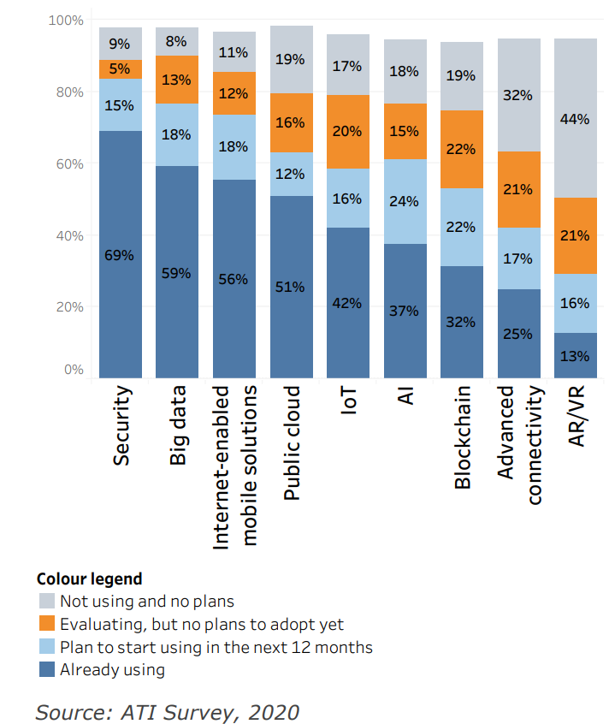 | 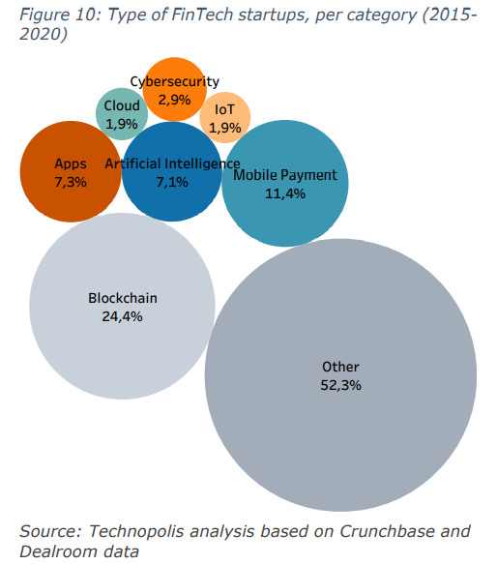

The structure of Latvia’s FinTech market
Latvia is a relatively popular destination in Europe for the companies of the FinTech field. According to the data of Index Ventures, Latvia is recognised as one of the most startup-friendly countries in the world. FinTech companies operating in Latvia have no geographical limitations and have successfully established companies (branches, representative offices) in other countries and continents around the world: EU Member States, Switzerland, the United Kingdom, Africa, Asia, especially in the fields of retail lending, payments and asset management.
The advantages of the Latvian financial sector include low operating costs (rent of office spaces, staff salaries) compared to Western European and Scandinavian countries, access to local banking infrastructure, capital raising opportunities and the licensing of financial market participants, including payment service providers (PIs, EMIs) carried out by the FCMC, which enables them to provide services throughout Europe without restrictions.
In addition to the licensing of financial services, the existing startup ecosystem in Latvia also provides other important elements for the development of the FinTech sector. First of all, the possibility to attract innovative startups from abroad through the Startup Visa mechanism within one month. The mechanism ensures a well-arranged relocation procedure developed by the LIAA and the OCMA (the LIAA is responsible for reviewing business plans of startup founders, while the OCMA makes the final decision on granting a TRP (temporary residence permit) after reviewing the applications of individuals). Secondly, Latvia has an attractive tax regime for startups, which can also be used by FinTech companies - for example, the income tax rate is 0 when reinvesting company profit. Thirdly, the startup ecosystem is strengthened by the regulation of stock options: a FinTech company can now grant stock options to its employees, thus attracting and retaining skilled staff in the field of technologies (IT specialists, web designers, engineers, digital marketing experts, etc.). The main purpose and advantage of applying stock options is to incentivise employees to increase the value of the company, improve employee performance and involvement through tax allowances in remuneration issues (if the legal requirements are met).
The availability of human resources is a strength of Latvia, but it has a tendency to reduce. Historically, human resources were concentrated in the field of credit institutions and IT services, which created prerequisites for the development of financial services. Such combination fosters the development of startups, focusing on new solutions in the fields of payments, investments, lending and crypto-assets.
Outsourced accounting services, customer support centres are also part of the ecosystem and contribute to the development of back-office functions because they offer access to digital infrastructure and human resources. Currently, there are more than 50 service centres in Latvia, employing around 15,000 employees in the IT area, field of finance and business support.
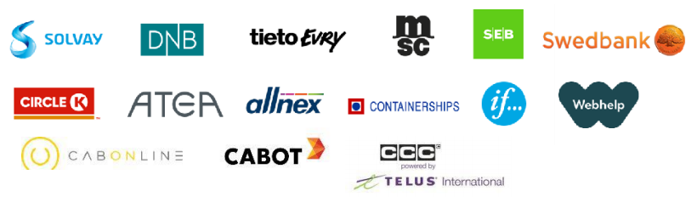
The growing development of the RegTech companies can be mentioned as another outsourcing branch supplementing the financial sector.
The structure of the FinTech landscape is diversified. There are currently around 100 active FinTech companies in Latvia (among more than 400 start-ups) in various entrepreneurship segments, such as payment services, lending services, investment platform and crowdfunding platform services, as well as data and analysis services. Financial software developers and IT companies, RegTech and supervisory technology (hereinafter also - SupTech) also form an integral part of the FinTech sector.

By type of entrepreneurial activity  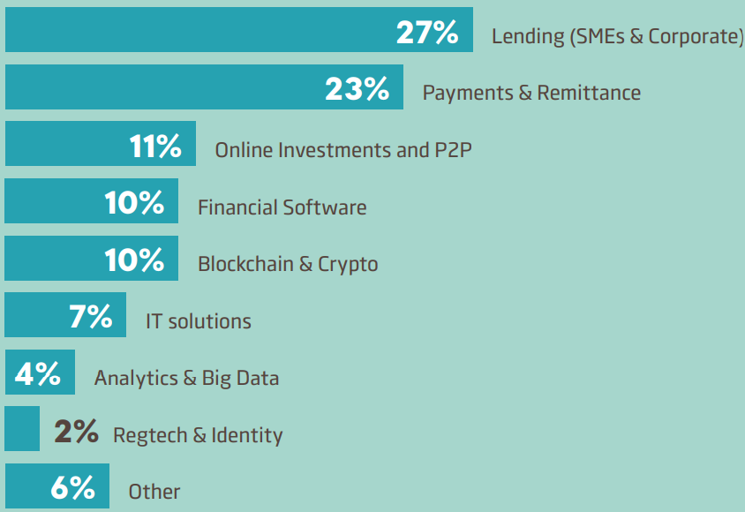 | Number of FinTech companies

Loans and online investment platforms are the dominant segment on Latvia’s FinTech map and are known to both local and international users.
The largest FinTech companies of Latvian origin gained worldwide recognition and are well known among individual and institutional investors. Examples include the investment platforms (investment service providers) Mintos Marketplace, being Europe's largest investment platform with over 6.7 billion euros in investments, as well as Twino, Viainvest, etc.; it is also worth mentioning the loan comparison portal Altero; Creamfinance, with a presence in 15 countries; and 4finance, specialising in consumer lending in 10 countries. Nordigen is the most successful open banking FinTech company, providing account information services and transaction categorisation services in 31 countries, connecting more than 1,000 financial sector participants through API solutions of the Second Payment Services Directive.
FinTech Sector Study published by the University of Latvia (hereinafter - UL) in 2020 allows the conclusion to be made that despite the rapid growth of the sector, Latvian FinTech companies are still relatively small and in the development stage. According to the UL study, 71.4% of Latvian FinTech companies are relatively new and were established in 2010 or later. At the same time, half of Latvia's FinTech companies have been established with national capital. Foreign capital is invested in 27 companies and it represents countries such as Cyprus, Estonia, Lithuania, Malaysia, Moldova, the Netherlands, Russia and Switzerland. The study notes that the combined turnover of Latvian FinTech companies in 2018 exceeded EUR 450 million and the range of turnover is large: from EUR 6.4 thousand to EUR 119.8 million. The companies with higher revenues were mainly set up as financial companies with foreign capital, and some are owned by corporate groups. More than half of the companies have fewer than 20 employees, with an average of 32 employees.
The following is perceived as key challenges by the FinTech companies:
- Regulation  - Qualified human resources  - Expansion to international markets  - Access to finance  - Finding customers  - Competition  - Costs of production or labour | 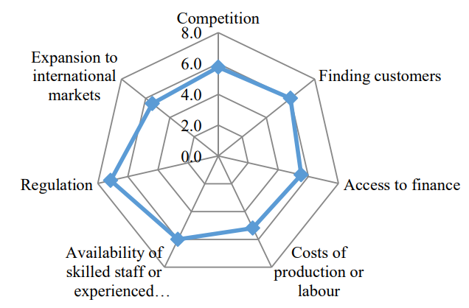
In terms of innovation development, the following trends can be observed in the financial market:
- innovative finance companies are active in several countries;
- application of platform business models, use of cloud technologies, software and server rental (SaaS (Software as a service)) is increasing;
- algorithms and data models, robo-advisors, chatbots, robotised automation;
- integration of artificial intelligence in lending and financial market and service supervision;
- application of FinTech outside the financial sector.
Business models of the FinTech companies are naturally based on virtual operations and remote communication with customers, which is essential in the Covid-19 era. Covid-19 stress still persists and continues to create uncertainty; however, on the other hand, new opportunities may arise for some FinTech companies. By being able to provide digital services remotely in the fields of investments, lending and payments, FinTech companies can strengthen their position compared to other service providers with low to medium levels of digitisation and with on-site service models. Trends in technology are not only creating new business opportunities and niches, but are also affecting the perimeter of supervision, creating new systemic risks. From a financial supervision perspective, financial technologies and services can be classified as follows:
Blockchains and crypto-assets | - Application of blockchain technologies in financial services  - Payments, exchange (stablecoins, CBDC, VC)  - Operations on crypto-assets
Capital markets | - Trading operations and automated derivatives transactions  - Raising capital, dealing in shares, bonds, securities and other long-term investments  - Capital market infrastructure tools
Infrastructure and safety | - Data and big data analytics software in the provision of financial services  - Cyber risk management in the provision of financial services  - Regulatory Technology (RegTech) and compliance technology
InsurTech (technologies used in insurance) | - Selling insurance policies in a digital environment  - Insurance policy comparison platforms and aggregators  - Data analysis software for insurers and reinsurers
Lending | - Digital loan platforms, crowdfunding platforms  - Applying innovative technologies to modelling of lending  - AI-powered credit rating tools
Payments | - Digital platforms enabling P2P, C2B, B2B payments  - Payment processing systems  - Faster, simpler, more integrated solutions
Personal finance | - Digital tools to help private individuals manage their finances, control spending and budget
Investment management | - Investment advice and investment management through technology  - Robo-consulting

Sectoral analysis

Payment and e-money institutions
In 2020, the payment and electronic money sectors (hereinafter also - PIs and EMIs) in Latvia demonstrated good resilience to the deteriorating economic situation under the influence of Covid-19. Both PI and EMI had been able to quickly relocate their operation to a virtual environment and support it remotely, and the operation of PI and EMI did not come to a halt. At the end of 2020, there were seven PI operating in Latvia, of which three were registered and four were licensed, and eight EMI, six of which were registered and two were licensed. The total amount of payments made with PI and EMI in 2020 reached 295.5 million euros - which is 26% more than in 2019, despite the consolidation that has been continuing in this sector since 2018, when the registered PIs and EMIs were invited to re-qualify and obtain the status of a licensed institution. In terms of customer service, PIs and EMIs in Latvia are divided as follows:
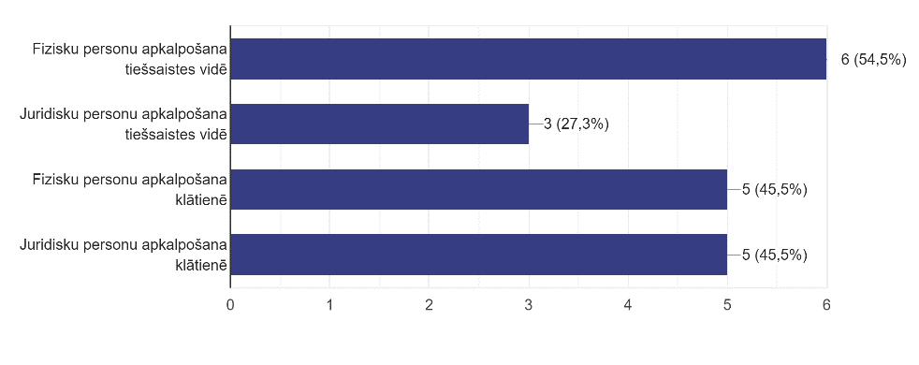
Online services for natural persons
Online services for legal persons
Onsite services for natural persons
Onsite services for legal persons
Number of EMIs and PIs and licences in 2020
 | NUMBER OF EMI & PI |  |  |  |  | EMI & PI LICENCES
 | 8 Number of EMI | 0 within 1 year | EMI -electronic money institutions |  |  | 2 Number of licensed EMI | 6 Number of registered EMI
 | 7 Number of PI | - 3 within 1 year | PI - payment institutions |  |  | 4 Number of licensed PI | 3 Number of registered PI
In 2020, the amount of payments made with e-money increased by 9%. Despite the negative impact of Covid-19 and related restrictions, the PI and EMI sectors managed to maintain their business and adapt to the new operating conditions, rules and operating regime. The Covid-19 pandemic had a negative impact on the amount of e-money repurchased, i.e., its exchange for money. This amount decreased by 24%, although the amount of e-money in circulation had practically not decreased compared to the end of 2019.
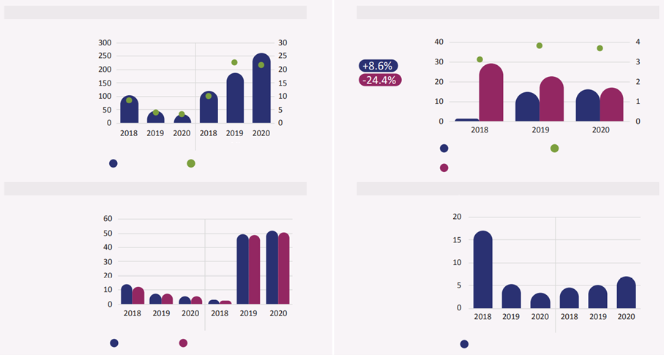
PAYMENTS WITH EMI & PI
E-MONEY CIRCULATION (EMI)
EUR million
EUR million
EUR million
EUR million
EMI
PI
PI
EMI
EMI
PI
Compared to 2019:
-25.4% (EMI)
+38.3% (PI)
Compared to 2019:
Compared to
2019:
-36.7% (EMI)
+34.9% (PI)
Liquid assets > current liabilities
Total amount of performed payments
Arithmetic value of payments made (right axis)
EMI & PI LIQUID ASSETS & CURRENT LIABILITIES
Total amount of payments performed with e-money
Amount of redeemed e-money
Average amount of e-money in circulation (right axis)
Liquid assets
Liabilities to service users
Gross revenue related to services rendered
EMI & PI REVENUE FROM RENDERING SERVICES
In 2020, the gross revenue of PI and EMI from the provision of services reached 10.3 million euros, about the same as in 2019. The amount of liquid assets also remained almost unchanged compared to the previous year and fully covered the liabilities of market participants to the customers.
Despite the fact that in 2020 the FCMC worked remotely, one licence was issued for the operation of EMI, one licence for the operation of PI and one EMI was registered. From the supervisory perspective, no restrictions or other additional requirements were introduced.

Crowdfunding platforms and investment platforms (investment service providers)
The crowdfunding sector is developing on a Pan-Baltic scale. Such type of funding offers additional possibilities for SMEs to raise capital for business needs, especially in situations where bank loans are not available, for example due to the lack of collateral. Both companies registered in Latvia and some companies registered in other countries (Estonia, Lithuania) operate in this field. These business models have broad geographical coverage across the EU. At the same time, it is important to note that Regulation (EU) 2020/1503 on European crowdfunding service providers for business has taken effect in November of 2020 (applicable from 10 November 2021), which governs the operation of crowdfunding service providers. The largest crowdfunding service providers in Latvia have obtained a licence of an investment firm.
According to data of the FCMC’s Innovation Hub, the largest number of crowdfunding service providers plan to use a loan-based financing model. In this case, a direct loan agreement (business relationship) is concluded between potential investors and project owners without the intermediation of a third party. This business model is more suitable for active SMEs looking to borrow money for current assets and long-term projects. Equity-based crowdfunding creates new financing opportunities for startups by offering investors the chance to invest funds in the capital of companies. In June 2021, only one potential market participant planned to develop such a business model.

- According to Dealroom data (2021), there were around 20 investment and crowdfunding platforms operating in the Latvian market.  - Most of the companies are registered in other countries (Estonia, Lithuania) and are subject to national supervision and legislation of the relevant country.  - Companies are linked to Latvia through the origin of their team, belonging of the ultimate beneficial owner or origin of capital.  - At the time of preparation of the assessment (June 2021), eight platforms were engaged in crowdfunding, focusing on the real estate segment and SMEs; and five were investment companies. | 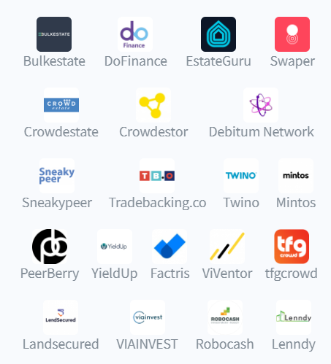
In 2020, the FCMC continued to work with potential investment firms - investment platforms - facilitating the adaptation of their activities to the requirements of the Financial Instruments Market Law, to take them under its supervision, thus ensuring investor protection. At the end of 2020, the following entities were entitled to provide investment services:
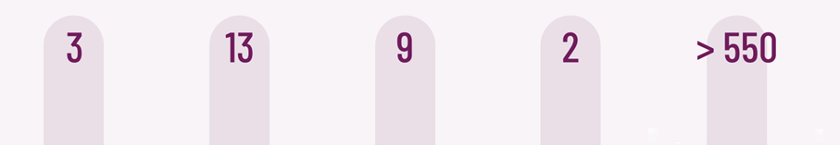
investment firms licensed in Latvia
credit institutions registered in Latvia
investment management companies firms licensed in Latvia
branches of credit institutions of EU Member States
investment service providers from the EEA countries under the principle of freedom to provide services
Latvia-based investment platforms
Ranking by size of the volume (EU) | Name | Funds raised, million (total) | Volume of transactions within the last 3 months (as at 30 June 2021) | Changes in volume for the last 3 months | Currency | Business model | Registration country
1 | Mintos | EUR 6,486.97 million | EUR 397.94 million | 9.44% | EUR | IF operating model | LV
4 | Twino | EUR 818.53 million | EUR 45.76 million | 13.21% | EUR | IF operating model | LV
8 | Peerberry | EUR 584.50 million | EUR 113.57 million | 23.12% | EUR | IF operating model | LV
13 | Viainvest | EUR 254.82 million | EUR 14.98 million | 32.52% | EUR | IF operating model | LV
40 | Crowdestor | EUR 52.59 million | EUR 3.04 million | -19.73% | EUR | Crowdfunding | EE
42 | Debitum Network | EUR 41.50 million | EUR 5.81 million | 8.95% | EUR | IF operating model | LV
57 | DoFinance | EUR 14.05 million | EUR 0.22 million | 58.34% | EUR | IF operating model | LV
76 | LendSecured | EUR 0.76 million | EUR 0.26 million | 302.86% | EUR | Crowdfunding | LV
Breakdown of transaction volume of investment and crowdfunding platforms, as at 30 June 2021. European market (more active platforms)

Private lending
There were 46 licensed non-bank lending companies operating in Latvia and specialising in consumer lending and financing of SMEs (data as of June 2021). In the first half of 2021, with 46 special permits (licences) for the provision of consumer lending services in Latvia, 42 consumer (nonbank) lending service providers issued new loans to consumers, including 17 companies issuing Distance Loans, 12 companies issuing Consumer Loans, 12 companies issuing Leasing and other loans related to security of a vehicle or other type of object, 7 companies issuing Loans against the pledge of movable property (pawn loans) and 7 companies issuing Mortgage Loans. Four companies with valid licences did not issue any new loans to consumers in the first half of 2021, with three of them providing administration for previously issued loans, and one submitting a zero report (see Table 1.2). In the first half of 2021, there were no new entrants to the consumer lending market, while six merchants left the market on their own initiative on 1 January 2021 and the CRPC withdrew a licence for one merchant, which was previously suspended for a period of 6 months. Within a month from the end of the reporting period, another five capital companies left the consumer (nonbank) lending market, therewith, as at 1 August 2021, only 44 special permits (licences) for the provision of consumer lending services are in effect.
In 2020, loans in the amount of EUR 500.95 million have been newly issued to private individuals in this segment, which is 16.13% less than in 2019. In total, in 2020, nonbank lenders issued new business loans to legal entities and consumers in the amount of almost EUR 812 million. The total loan portfolio quality has already been stable for four years.
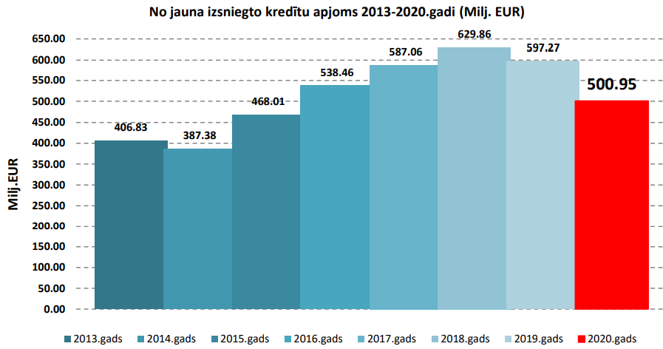
Volume of newly issued loans 2013-2020 ( EUR million)
EUR million
2013
2014
2015
2016
2017
2018
2019
2020

According to Dealroom data, the most important nonbank lenders in the FinTech sector are CreamFinance, Mogo, 4Finance, SunFinance. The referred to companies are also successfully expanding outside Latvia in several countries.  These companies use innovative data science technologies in operation in data and risk management and integrations with outsourced service providers. For example, SunFinance Group processes around four million loan applications per month and has achieved one billion euros in the total sum of the issued loans. | 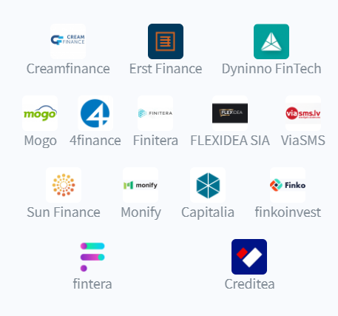
Other service providers SIA VIA SMS, SIA Extra Credit, SIA Delfin Group could be considered as FinTech companies.
A survey commissioned by CRPC shows that people most often mention convenience, speed, less formalities and flexibility among reasons for choosing to borrow from non-bank lenders rather than from banks.

Easy and fast loan processing*
Possibility to borrow a small amount of money
No need to arrange various formalities (statements of work, certificates from the SSIA (State Social Insurance Agency), etc.)
No need to explain the purposes of the loan, no feeling of humiliation when asking for a loan
Possibility to borrow for a very short period of time
No need to ask friends, family, acquaintances to borrow money
Possibility to freely choose the most suitable combination of amount, term and interest
Favourable loan conditions for new customers (interest-free loan, possibility to return the same amount as borrowed, etc.)
Possibility to extend the repayment term conveniently and easily
No large, regular and/or official income required
Low/affordable loan interest rates
Non-bank lenders offer various discounts/promotions for loyal customers (e.g., birthday discount, etc.)
No need to worry about repayment because nonbank lenders would not be very eager to collect money anyway

Crypto-assets service providers
Despite the impact of Covid-19 on the global and Latvian economy, the crypto-asset market is proving its viability (e.g., Bitcoin, Ethereum). Blockchain technology, in turn, is gaining wider application in the field of payments, security and investments. In general, crypto-assets can be used for the following purposes:
- as a means of payment, exchange or storage of assets (payment tokens);
- as an investment instrument (security tokens);
- as a tool to access a digital platform, goods or services (utility tokens).
The Latvian crypto-asset market is at the early stage of development, with around 20 companies operating therein. There are some providers, such as Blobitex, which provide crypto-asset exchange (stock exchange) services. Fintelum provides crypto asset-based investment services, while Datagnition focuses on blockchain data analysis services, using machine learning and artificial intelligence technologies.  Other financial market participants are developing crypto-asset storage (e-wallets) management, intellectual property security tools and crypto-asset investment and payment services. | 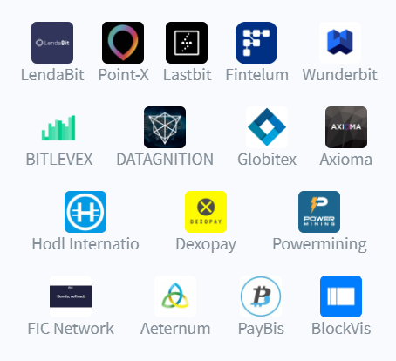
Despite the limited number of participants, the application of artificial intelligence and machine learning technologies is the fastest growing in this segment.
In monetary terms, the volume of Latvian crypto-asset transactions cannot yet be tracked due to decentralised financial technology and the lack of unified supervision of the activities of these service providers. Compared to Estonia and Lithuania, Latvia has a smaller number of companies operating in the field of crypto-assets. It should also be noted that blockchain technologies in Estonia are more widespread in the public administration sector: the operation of Healthcare Registry, Property Registry, Business Registry, Succession Registry, Digital Court System, the State Gazette is backed by blockchain technology.

RegTech and IT sector participants
The RegTech market is growing rapidly on a global scale, and several companies in Latvia are also currently working on the risk management solutions in the field of compliance. Such solutions enable automating KYC (know-your-customer) processes and the tools for control and management of AML/CTPF, which in turn saves time and resources for both financial sector participants and their customers. For example, it is possible to develop a solution or process making the process of commencement of customer relationship in a credit institution easier and more modern, and strengthening compliance management in the financial institution.
As part of the development of industry dialogue, a significant number of consultations in the FCMC’s Innovation Hub is provided to RegTech creating new solutions for financial sector participants and helping to significantly improve risk management, control, monitoring processes and reducing the risk of human error.  RegTech solutions developed in Latvia provide, for example, automation of AML/CTPF checks, transaction supervision, customer reputation due diligence tools. The emerging solutions are based on a technology-driven approach and provide a higher degree of digitisation in the management of compliance processes, inter alia, such RegTech solutions can be used as outsourced service providers for licensed financial market participants.  Regulatory technology helps to automate and manage regulatory compliance, business continuity of financial market participants, information systems security, reputation control and assessment processes, and risks related to internal control systems. For example, the number of Smart-ID users in Latvia has reached one million (May 2021). |  | 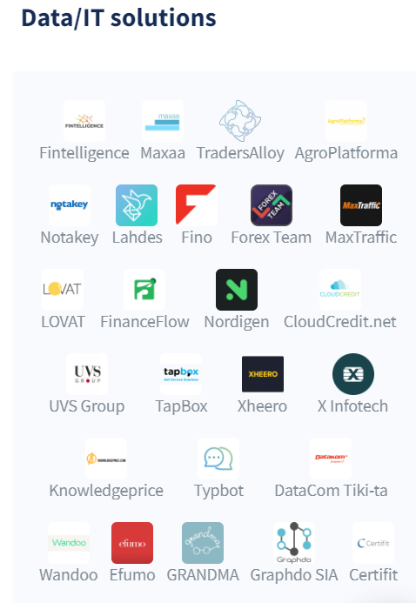
RegTech solutions complement the development of the IT sector - the sector ensures the development of software for the purposes of providing financial services. According to data of LIKTA, companies operating in the ICT sector generate annual turnover of 4.2 billion euros, earn 426 million euros and employ nearly 37,200 employees. It should be noted that half of the services provided (847 million euros) and products sold (1.2 billion euros) are exported, placing the ICT sector among the TOP 3 exporting sectors. | The ICT sector in figures:  - Number of ICT companies 6,990+  - ICT labour costs 700+ million euros  - Number of employed in the ICT sector 37.2 thousand  - ICT sector profit 426+ million euros  - Of GDP 4.6%  - ICT sector taxes (Q1 2020) 8.2%  - ICT turnover 4.2 billion euros
Both local and also well-known international IT industry companies such as Accenture, Evolution, Mikrotik, Oracle, Emergn, Playtech operate in Latvia. Overall, the IT industry supports the financial sector with a wide range of software for CRM systems, ERP and core systems for the needs of processing payment cards and account transactions, as well as solutions for managing online banking and payment systems. Risk management systems and technologies that enable the prevention of fraud and money laundering are becoming increasingly important.
Rapid IT development is driving the creation of innovation and new services in the FinTech sector and facilitating the use of digital infrastructure, such as cloud services, big data processing. According to Tet data, demand for cloud services grew by 15% in 2021, following a 10% increase in 2020. According to Tet, many companies that have gained experience in remote working will choose to stay online.
The financial sector has historically operated with large data volumes, which are only increasing as the level of digitisation of processes grows, and the sector will become even more data-dependent in the future. Operational directions using big data:
- improving customer experience and service;
- staff work efficiency;
- optimising, automating business processes;
- risk management, fraudulent transaction alerts, field of security with respect to IT activities and management of cyber risks.
Big data analytics is widely used for financial services to make higher quality decisions in the retail segment or in the field of investments and securities to maximise portfolio return. In the insurance sector, big data helps to analyse and predict customer behaviour by collecting large data volume from external sources, allowing a focus on personalised offers.
As the demand for big data processing grows, so does the number of data centres - for example, the largest data centre service provider in Latvia, Tet, currently operates five data centres. Other service providers providing data centre services include DEAC, iPro, Telia, Latvian State Radio and Television Centre, BITE and others.

Assessment of Latvia’s FinTech ecosystem
Successful development of the FinTech sector requires a well-functioning ecosystem, corporate responsibility and swift decision-making. The following stakeholders are the beneficiaries of the FinTech sector.
FinTech companies | Develop new business models, drive innovation, create new financial products and services, improve the financial system, break the old operational methods, types of service provision and business models, modernise the market, by offering intuitively easy, fast and convenient solutions.
Consumers, private individuals and SMEs | Receive more suitable and personalised financial services digitally and in the most convenient way.
Investors, equity funds, financiers | Invest in and finance the FinTech companies at an early stage, earn from the increase of value of FinTech companies (exit x 3-5).
Support markets  (RegTech, ICT) | Provide infrastructure, reduce costs by offering services (outsourcing) to FinTech companies (for example, automation of the ML/TPF risk assessment, scoring models, data analysis and open data services, data centre solutions).
Business incubators, startup accelerators | For a certain period of time, help new companies to develop, scale their business models and ideas to other countries, provide expert advice, advisory function, help with product or service testing and go-to-market strategy.
Financial institutions | Opportunity for insurance companies, asset managers, banks to work together with FinTech companies to improve the quality of their services by offering more advanced services to their customers.
Education institutions | Opportunity to train professionals who will be able to combine IT and financial expertise with a focus on high value-added services.
Talents, human resources | IT professionals are in demand in all sectors of the Latvian economy. Cyber risk analysts, developers, digital marketers, data analysts, product owners, etc. Demand exceeds supply.
Country | Tax payments, improvement of the level of welfare, employment, economic and export development.

The quality of cooperation of the stakeholders themselves can shape successful FinTech ecosystem comprised of four essential elements. Each stakeholder can make an input to one or several elements, ensuring the functionality of the ecosystem.

Regulation  Infrastructure and technology  Education and talents  Capital accessibility  FinTech | Regulation - embedded regulation of financial services, inter alia, the national policy of sectoral growth initiatives, including support for startups, innovative business models.
 | Infrastructure and technology - infrastructure maturity, support from the technology community and state support mechanisms for the development of innovative financial technologies.
 | Capital accessibility - accessibility of financial resources for newly established technology companies (startups) from the seed money to entry to the market.
 | Education and talents - availability of financial services and talents in academia, ability to attract, develop and retain talents, including experienced talents and workforce.

Regulatory assessment
In 2018, the European Commission adopted a FinTech Action Plan for a more competitive and innovative European financial sector. The main objective of the Plan is to increase supervisory convergence as regards technological novelties and to prepare the EU financial sector to benefit from new technologies.
All new EU legal acts must be based on the “innovation principle”. The European Parliament stresses that, in order to avoid regulatory arbitrage, legal acts and supervision in Member States should be based on the following principles:
• same services and risks: uniform rules should apply regardless of the type of a legal entity concerned or its location in the EU;
• technology neutrality;
• a risk-based approach, taking into account the proportionality of legislative and supervisory actions to risks and the materiality of risks.
Supervisory authorities around the world are striving to find the optimal balance between rules ensuring adequate safeguards and implementation of growth and innovation in the financial sector. This balance is influenced by several elements, such as:
- a growing number of FinTech companies is likely to increase competition in the supply chain of banking services; while fragmentation of banking services may increase operational risks in the business model;
- application of cloud computing could increase the efficiency of systems of the financial sector participants, but it could also increase systemic risk. More specifically, the risk in the case of cyber attacks, when several banks outsource the service to the same service provider;
- automation of new customer attraction processes (“know your customer” requirement) and the use of RegTech technologies can widen the availability of financial services, at the same time increasing the data protection risk;
- algorithm-based credit rating determination methods based on data sources reduce the necessary human resources, but also pose privacy and data leakage risks;
- crypto-assets could reduce the costs of cross-border payments, but at the same time pose significant ML/TPF risks and tax risks.
Depending on their business model and types of financial services, FinTech companies are regulated and supervised by the FCMC, the CRPC (consumer lending), the State Revenue Service (crypto-asset service providers). A single European approach to the regulation of payment service providers strengthens competitiveness, market development and a level playing field in both the EU and Latvia. FinTech companies can currently obtain licences from the FCMC to provide payment and e-money services, to operate investment platforms and also for other fields, depending on the structure of the business model and the planned innovation in the particular idea.

Regulation of payment and e-money institutions
The activities of payment and electronic money institutions are regulated by the Law on Payment Services and Electronic Money, which sets out the payment services that may be provided by a commercial company that has obtained a licence from the FCMC, as well as the cases when a payment institution is not required to obtain a licence to start its operation and is registered in the register of institutions maintained by the FCMC.
The FCMC shall take a decision on the issuance of a licence within three months of receipt of all the necessary documents. The existing regulation of the field of payments is uniform across Europe, which in turn enables local FinTech companies to operate throughout the EU by obtaining a licence in Latvia.
Open cooperation or open banking: where a licensed payment institution provides only an account information service, it is not required to hold initial capital, while ensuring that the institution's own funds are not negative. In order to provide an account information service and/or a payment initiation service, a payment institution is required to insure its professional third-party liability.

Regulation of crowdfunding services
Based on Crowdfunding Regulation (EU) 2020/1503, the FCMC has been designated as the competent authority for the registration and supervision of crowdfunding service providers under the national Crowdfunding Services Law. The requirements for crowdfunding service providers are set out in the Regulation on European crowdfunding service providers for business ((EU) 2020/1503). The Crowdfunding Services Law, by which the requirements of the Regulation will be applied in Latvia, was adopted on 7 April 2022. Regulation 2020/1503 is applicable from 10 November 2021. The new framework sets out the key principles of requirements and regulation, while the RTS and ITS set out more detailed requirements on complaints handling, conflict of interest, business continuity plan measures and procedures, licensing, calculation of default rate, investor entry knowledge test and simulation of the ability to bear loss, key investment information sheet and reporting to be carried out by the service provider on the projects financed on the platform, as well as on the notification of national rules on marketing requirements to ESMA.

Regulation of credit services
The provision of consumer credit services is regulated by several laws and regulations, inter alia, the Cabinet of Ministers Regulation on the Special Permit (Licence) for the Provision of Consumer Credit Services, Regulations Regarding Distance Contracts for the Provision of Financial Services, Regulations Regarding Consumer Credit. Licensing and supervision of consumer credit service providers is carried out by the CRPC. Any company, including a FinTech company, must obtain a permit for the provision of consumer credit services, if it wishes to provide consumer credits. Consumers are not allowed to lend to a consumer through the activities of crowdfunding service providers.

Regulation of investment services
An investment firm providing investment services and non-core investment services shall comply with the Financial Instruments Market Law, the FCMC regulations and the administrative acts issued in respect thereto, as well as internal policies and procedures. An investment firm providing investment services in financial instruments listed on a regulated market shall also comply with the rules of the relevant market organiser. The minimum initial capital of an investment firm is between 50,000 and
730,000 euros, depending on the selected types of investment services. The FCMC shall take a decision on the issuance of a licence within six months after all the documents prescribed by law for the adoption of a decision have been duly executed and received.

Crypto-assets regulation
Currently, in order to provide cryptocurrency services, including the issue, holding thereof and payments with it, it is not necessary to obtain a special permit in Latvia, but, at the same time, the service provider must register with the SRS and comply with the requirements of the Law on Prevention of Money Laundering and Terrorism and Proliferation Financing. In the case that the crypto-asset manager plans to carry out activities comparable to a regulated market in Latvia, it must obtain one of the authorisations in the relevant field. Since Q3 2020, the EU has been working on the MiCA (Markets in Crypto-Assets Regulation) single framework, which will replace national legal frameworks on crypto-assets once it is developed.
The MiCA framework aims to regulate the digital representation of a value or right that can be shared or stored electronically using distributed ledger technology or similar technology. Crypto-assets, which are already defined as financial instruments or electronic money under the Markets in Financial Instruments Directive (MiFID) and the Electronic Money Directive (EMD), are not covered.
New regulation of crypto-assets will:
- ensure legal certainty as regards crypto-assets that are not covered by existing EU financial services legislation and for which there is now a clear need;
- set uniform rules at the EU level for crypto-asset service providers and issuers;
- replace the existing national laws that apply to crypto-assets not covered by current EU financial services legal acts;
- develop specific rules for the use and maintenance of the so-called stablecoin.
The MiCA framework will foster cooperation between countries, provide greater regulatory certainty for market participants engaged in cross-border activities and help further innovation and consumer choice in the field of financial services.
New regulation of crypto-assets will help ensure a high level of consumer and investor protection, market integrity and financial stability, and the application of anti-money laundering requirements between participants involved in crypto-asset transactions.

Regulation of IT security risk management
IT security in the financial sector regulated by the FCMC is regulated by FCMC Regulation No. 150 Regulations Regarding Information Technology and Security Risk Management. The regulations are aimed at mitigating to an acceptable level the risks of information technology applied for ensuring the operation of market participants and services provided to customers and improving the IT and security management, in general, striving to achieve prudent level of risk management (risk appetite), as well as at establishing single structured IT and security management requirements for market participants. The Regulations are binding on all financial and capital market participants supervised by the FCMC and registered or licensed in Latvia: credit institutions, credit unions, payment institutions, electronic money institutions, insurance and reinsurance companies, insurance and reinsurance intermediaries, private pension funds, regulated market operators, central securities depositories, investment firms, investment management companies and alternative investment fund managers.
In September of 2020, the European Commission published the draft regulation on the Digital Operational Resilience Act or DORA. DORA is part of the Digital Finance Strategy of the European Commission, aimed at supporting the development of digital finance, at the same time mitigating the associated risks. The legislative proposal is based upon the current IT risk management requirements already developed by other EU institutions, and brings together in a single framework, several recent EU initiatives on IT incident reporting, security testing and third-party service management to create a harmonised approach across the entire EU financial services sector.
DORA will apply to a very wide range of financial institutions, including credit institutions, payment institutions, electronic money institutions, investment companies and investment firms, crypto-asset service providers, alternative investment fund managers, insurance and reinsurance companies, insurance intermediaries, crowdfunding service providers. It is important to note that DORA will impose a number of additional requirements for incident reporting, security testing and third-party service management. As a result of the implementation of DORA, the critical IT third-party service providers, including cloud service providers, will become subject to the supervision of European supervisory authorities for the first time, including the possibility for the EU authorities to take administrative measures and impose sanctions on an IT service provider for non-compliance with the requirements prescribed by the regulation.
DORA requirements can be divided into four basic directions.
- IT risk management. This includes harmonising the requirements of IT risk management laws on the basis of common guidelines, such as the IT and security risk guidelines issued by the EBA.
- IT incident reporting. This direction provides for harmonising the incident reporting framework, including incident classification and reporting requirements. It will give financial institutions and regulators a better picture of emerging risks, threats and the ability to exchange information.
- Third-party ICT service providers’ risk management. This direction stipulates to apply regulatory requirements also to the third-party critical IT service providers.
- Operational resilience testing. This direction involves harmonisation and standardisation of digital operational resilience testing requirements - observing a risk-based approach, companies should implement assessment, testing, methodologies, solutions and tools that are appropriate to the size, business and risk profile of the organisation.
The DORA framework is currently being forwarded to the review through the EU legislative procedure. The final version of DORA is expected in the next 18 months. Financial sector companies already now should start assessing how the new regulation would influence their IT risk management system and plan the necessary measures to comply with DORA regulation.

Support mechanisms
In order to support and develop the FinTech sector, it is the objective of the FCMC, in cooperation with other state institutions, to create a FinTech-friendly environment that would promote innovative financial services in Latvia. Two support mechanisms have been established for implementation of the goal. Innovation Hub and Regulatory Sandbox

Innovation Hub
The Innovation Hub is a special contact point for financial companies to raise questions in the FinTech area and receive binding guidance on the compliance of innovative financial product, service or business model with licensing requirements, supervision and other laws and regulations (inter alia, on payments, AML/CTPF, IT security, crypto-assets, etc.). Since the end of 2017, the FCMC experts have provided 230 consultations at the Innovation Hub.
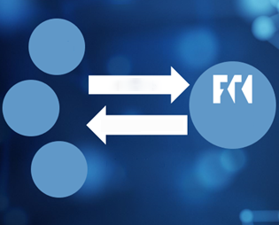  FinTech  RegTech  SupTech  Innovation Hub  Legislation  Licensing  Regulation  IT security  AML  FINANCIAL AND CAPITAL MARKET COMMISSION  Requests  Providing support | 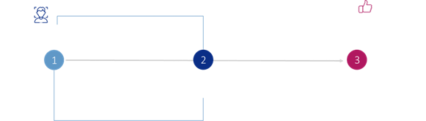  Initial assessment of the application and meeting with the customer  Experts assess questions/information and provide advice, attracting other experts from the relevant fields  Satisfied customer who received the FCMC’s expert advice; new solution ready for sale
In 2020, the experts of the Innovation Hub experts provided 40 individual consultations to financial companies. Compared to 2018 or 2019, the number of consultations in 2020 dropped by around one third due to the impact of Covid-19. In 2021, an increase in consultations can be observed again, with the number thereof reaching 30 in July 2021. Steady interest is observed in subjecting new services or business models to some form of financial sector regulation: interest is larger in the field of payments, with a particular focus on the supervisory requirements of the regulated financial sector and the application of, and compliance with these requirements in practice. Innovation Hub experts assess and explain the potential challenges of the ideas to be addressed during further development, as well as explain the requirements on licensing issues.
According to the FCMC Innovation Hub’s statistics, by the end of Q2 2021, the highest number of consultations was provided to crowdfunding service providers and RegTech business originators. The FCMC sees trends in the fields of compliance and risk management that ensure automation of the AML/CTPF processes and anti-money laundering tools, thus saving time and resources. RegTech tools help FinTech companies and other financial market participants to automate and improve their AML/CTPF processes.
From early 2021, there has been an increased interest observed in the regulation and licensing process of crowdfunding platforms.

Regulatory Sandbox
The Regulatory Sandbox provides existing or potential financial market participants, whose operation requires an operating permit (licence or registration) from the FCMC, with the opportunity to test and verify innovative financial products, financial services or business models according to a specific testing plan agreed with the FCMC.

Regulatory Sandbox  • For a limited period of time, for a limited group of consumers  • For the companies of any sector (insurance, FinTech, investment services, payments)  • Must be a test partner  • Consumer protection during testing | Sandbox is open to all financial service companies, whether they are supervised players or new entrants.  Innovation can come from applying technology, but this is not a prerequisite to qualify for the Sandbox. Sandbox is open to innovation, which has a positive impact on a sound financial sector.

So far three applications have been submitted to the Sandbox, one of which has been approved in 2020 and the other two have been redirected to Innovation Hub consultancy. The approved applicant planned to conduct RegTech tests in the FCMC’s Regulatory Sandbox for the AML/CTPF solution related to the analysis of customer account transaction information. The testing plan has been completed in 2021.

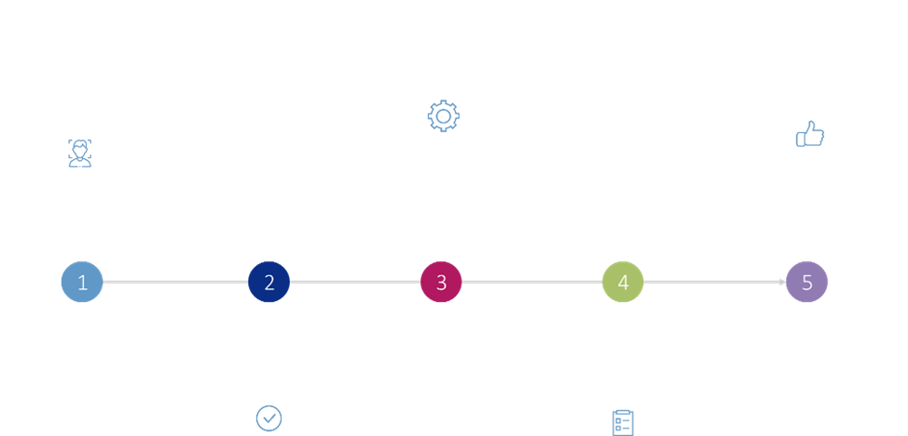
Initial assessment of the application and meeting with the applicant
Operation of the Regulatory Sandbox of the FCMC
Testing stage and a parallel licensing process takes place or
First comes the licensing process, then the approval of the test plan, and then the testing stage
Result:
new licensed/registered and supervised financial market participant / new innovative service
Up to 10 business days
Decision of the Financial Innovation Committee on further steps and the approval of the test plan
3-6 months
The applicant submits the test results. Board decision on further steps
Up to 30 business days

Sandbox provides a controlled environment for testing innovative financial products and services (regulatory regime), enables a better understanding of financial services companies and technologies, as well as provides the possibility to identify, assess the risks related to new services and business models that are not protected by the current regulation, and to ensure compliance with laws and regulations. Sandbox allows the identification of legal barriers decelerating the development and stability of new services, as well as allows strengthening of the stability of the financial system and protecting the interests of service users.
In 2021, the EBA also plans to publish a framework to support cross-border sandbox testing, which is currently being developed by the EBA's innovation sub-group - the European Forum for Innovation Facilitators. The framework will support companies that intend to involve several competent authorities in the testing process (e.g., through shared testing or structured test observation and discussion of findings).
Ilab - internal innovation laboratory of the FCMC
In order to facilitate the application and acquisition of new technologies, in 2021, an experimental (pilot) technology laboratory was also established in the FCMC, where projects that would improve the FCMC’s supervisory process and expert competences were implemented. The first projects were implemented in 2021.

Open cooperation or open banking
FinTech companies have the opportunity, in cooperation with the banks, to develop more personalised and innovative payment offers for banking customers with the open banking solutions offered by the second Payment Services Directive or PSD2. Open banking has also been introduced by several Latvian commercial banks (Swedbank, SEB, Luminor, Citadele, Signet) and a licensed payment institution (Nordigen). It enables users to better manage their finances through account information and payment initiation payment services. Open banking solutions enable FinTech companies to integrate banking services into the already existing digital products, such as accounting systems, business management and budgeting software, and to tailor banking products to specifically defined customer needs.
Regulated FinTech companies with whom banks have API integrations in the Latvian market
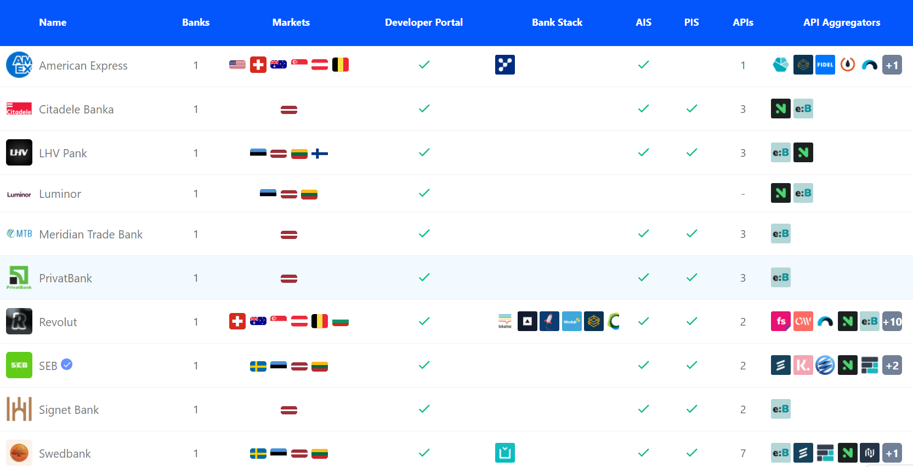

Other auxiliary tools
Law on Aid for the Activities of Start-Up Companies or the Start-up Law The Start-up Law approved in Latvia is now more friendly with a unique tax regime that allows attraction of the most talented programmers, designers, developers at low cost, using social tax incentives. Only 340.90 euros per month are paid for the employee and the personal income tax allowance is being applied (0% personal income tax rate). This means that even paying the salary in the amount of two minimum wages saves money. Another benefit of this Law is state aid of up to 45% for the co-financing of high-level specialists. The sector is young and dynamic. About 80% of all investment is foreign and come from the USA, Estonia, the United Kingdom, Russia and the UAE.
To become eligible, a start-up needs to demonstrate that work is underway to develop an innovative product/service. The aid programme period is 12 months or 24 months if the start-up, having received an early stage venture capital investment, must receive an investment (EUR 15,000 - 30,000 from a qualified venture capital investor) and/or demonstrate that work is underway to develop an innovative product/service.
Start-up visa Currently, Latvia has one of the most progressive startup regulations in Europe, which allows the attraction of innovative companies with the startup visa tool developed by LIAA for every innovative startup willing to move to Latvia; there are also restrictions set for obtaining the startup visa in Latvia - it is issued to no more than five foreigners to implement the same activity in a startup. The application process takes one month and the visa is issued for up to three years. The main criteria for a startup visa is the innovative (most often technology-based) idea that is easily adaptable and creates high added value.
Stock option tool This tool allows companies to attract highly qualified professionals in the long term and to boost motivation. Along with the development of the company, the value of the employee stock option also grows. If a company organises an IPO (initial public offering), employees receive additional remuneration. The tool provides an opportunity to retain in Latvia both high value-added technology companies and loyal professionals who are interested in the company generating profits.
According to Swedbank FinTech Report 2020, the FinTech companies in the assessment on the state aid positively assessed the access to business incubators, while as regards financial incentives, the startup visa mechanisms need certain improvements:
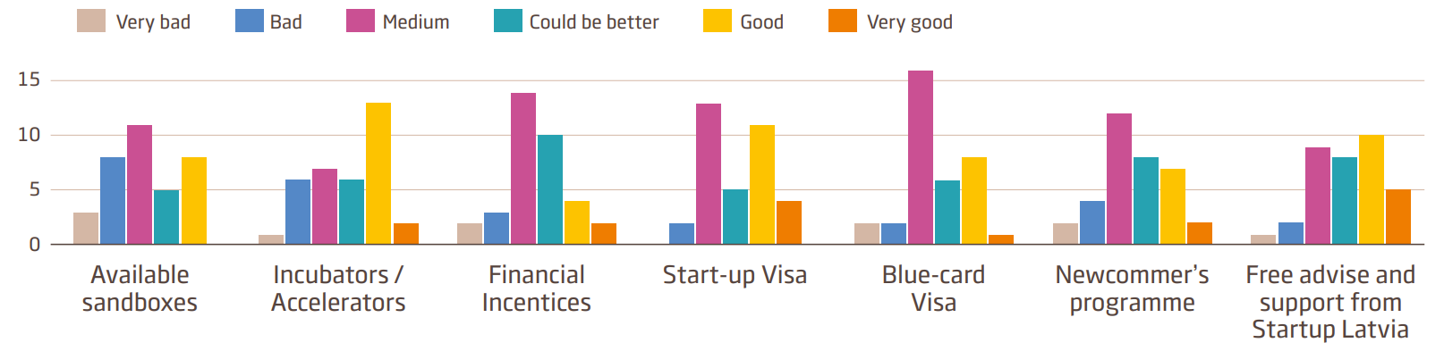
Among other support mechanisms that encourage the development of startups and complement the common infrastructure the following may be mentioned:
- professional associations (LMENA, LIKTA, LAFPA, LFNA, LABA, LPABA, ANFSP);
- LIAA provides support for the commencement of entrepreneurial activity and development to natural persons and newly established merchants through 12 regional business incubators and 9 support units. It should be noted that FinTech companies are not the focus of the mechanism. In turn, for information technology startups, there are several information technology meet-up venues, being the largest on a pan-Baltic scale: DevTernity, Riga DevDays, Devops Days Riga, UX experience – UX Riga, 5G Techritory, Riga Comm, Wordpress WordCamp Riga, Accenture Bootcamp;
- co-working space service providers (around 13 co-working spaces), which operate according to different operating models. For example, TechHub Riga offers co-working spaces for tech startups, internal support, expert advice and access to the international TechHub network;
- TechChill - a non-governmental organisation that organises events related to startups and promotes the international recognition of the Latvian ecosystem;
- Riga Tech Girls supports and trains women in technology environment, organising meet-ups and workshops, with an average of 20 events being organised per year.

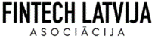
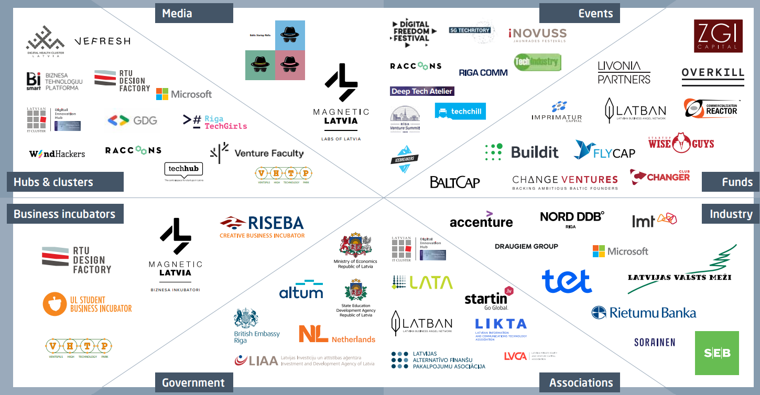
Figure ‎1.1, Startup ecosystem in Latvia

The impact of digitisation of the economy
Data use and analysis of data will contribute to the development of competencies, talents and the financial sector. Since 2014, the European Commission has monitored Member States’ progress in digital, by publishing the Digital Economy and Society Index (DESI). The index includes analysis on broadband connectivity, digital skills of population, internet use, digitisation of enterprises, digital public services, integration of technologies. Latvia ranks 18th among the 28 EU countries. Compared to DESI 2019, Latvia has dropped three places down.
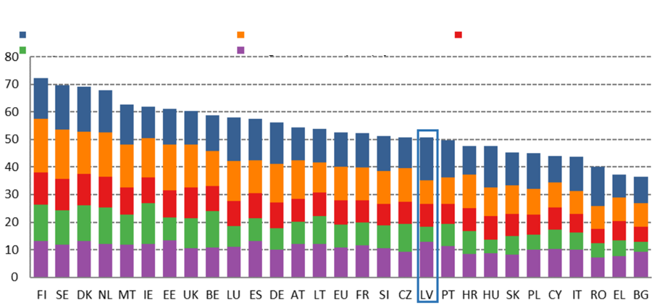
1. Connectivity
4. Integration of digital technologies
Digital Economy and Society Index (DESI), 2020 ranking
2. Human capital
5. Digital public services
3. Use of internet services
As regards digital public services, Latvia ranks 5th. All of Latvia's indicators in this area are above the EU average. Online public services are provided with automatically partially pre-filled forms, services to be provided fully online, services for businesses. For example, a person willing to register a company online can submit all the necessary documents to the Enterprise Register. The progress indicator in the open data area is also good - 75% (EU average - 66%).
 | Latvia |  |  | EU
 | DESI 2018 value | DESI 2019 value | DESI 2020 value | DESI 2020 value
5.a.1. e-Government users | 77% | 81% | 83% | 67%
% internet users, who need to submit the forms | 2017 | 2018 | 2019 | 2019
5.a.2. Automatically partially pre-filled forms | 71 | 83 | 86 | 59
Score (0 to 100) | 2017 | 2018 | 2019 | 2019
5.a.3. Services to be provided fully online | 91 | 94 | 96 | 90
Score (0 to 100) | 2017 | 2018 | 2019 | 2019
5.a.4. Digital public services to enterprises | 93 | 90 | 90 | 88
Score (0-100) including both domestic and cross-border cases | 2017 | 2018 | 2019 | 2019
5.a.5. Open data | no data available | no data available | 75% | 66%
% of maximum score |  |  | 2019 | 2019
According to the report, Latvia scores well on digital public services and connectivity. The quality of e-Government services has continued to improve over the past year and the number of users thereof has increased. Latvia has a very good broadband coverage with fast, very high capacity networks, and the radio frequency spectrum has already been assigned in the country for ensuring 5G. Although the fixed broadband take-up is generally low, 38% of households have subscribed to at least 100 Mb/s broadband connection compared to the EU average of 26% of households.
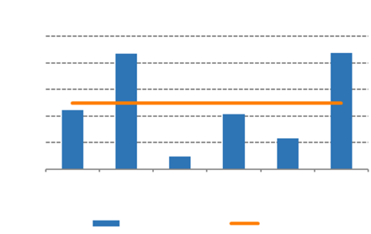  Country with the highest score  DESI 2020 relative performance by area  Country with the lowest score  DESI  1.  Connectivity  2.  Human capital  3. Use of internet services  4. Integration of digital technologies  5. Digital public services  Latvia  EU 28 | Despite this, the opportunities offered by digital technologies are still not widely used in the Latvian business sector. Latvia ranks 23rd in the integration of technologies in enterprises. Only 8% of companies use big data technology, 19% of companies have social media activities and 11% use cloud services. Moreover, only 11% of SMEs trade online and only 5% of SMEs’ turnover comes from e-commerce. As regards digital skills, Latvia’s indicators are quite below the average, as well.
More than half of the population still lacks basic digital skills and only 1.7% of the total workforce are ICT professionals (the EU average is 3.9%).

Capital accessibility
The financial sector is the largest developer of digital technologies and a major contributor to the digitisation of the economy. Although financial innovation is not new, investment in technology and the pace of innovation have increased significantly. Financial technology solutions are changing widely, altering the financial sector and the way consumers and businesses access services. FinTech has been European largest capital investment category in recent years, attracting more than 30 billion euros in venture capital investments since 2014.
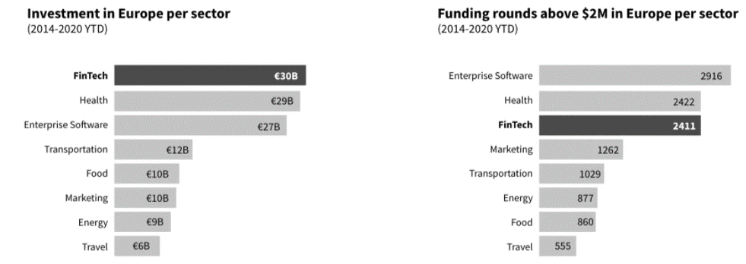
Capital Raising Trends in Europe in FinTech Sector during the Pandemic (2019-2020).
- European FinTech companies raised a total of 3.52 billion euros in 2018; in 2019, this figure increased by 150% to 8.81 billion euros.
- In the first half of 2020, European FinTech companies raised around 4 billion euros, comprising more than in 2018 in total, but still below 2019, when more than 8.8 billion euros was raised in funding.
- Previous studies show that the funding in the FinTech category in Europe is allocated at all stages of development. While Tech.eu tracked only four FinTech financing transactions in Europe worth more than 100 million euros in 2018, this number increased five times in 2019 alone.
- The strong growth in Europe was largely driven by FinTech companies raising development funding (+15 million euros) and transactions on closing of financing in the amount of 100 million euros. The initial funding rounds (less than 15 million euros) actually decreased over the period of all three years.
- In the first half of 2020, Tech.eu tracked 219 FinTech funding rounds, indicative of a record for the year.
- Volumes of FinTech funding rounds are growing rapidly: the average volume of funding per round more than doubled over the period analysed, from around 11 million euros in 2018 to 25.5 million euros in 2019.
Top 20 EU and non-EU countries by investment volumes in the FinTech sector (2017 - first six months of 2020)
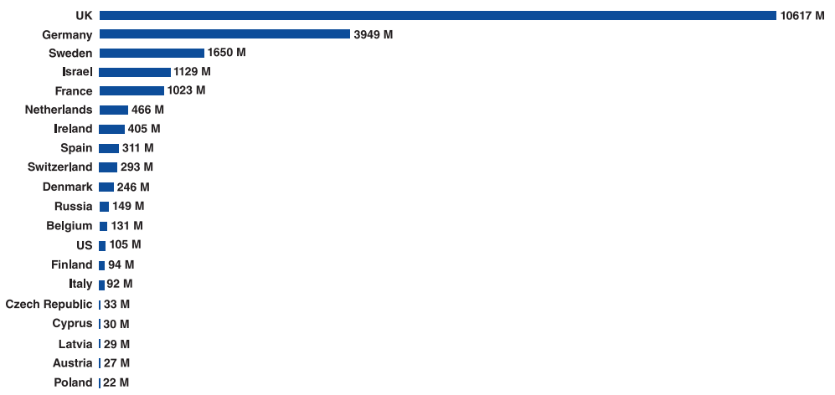

The Latvian capital market is still underdeveloped. Judging by the stock market capitalisation against GDP, Latvia is in last place among the EU countries, lagging significantly behind the neighbouring countries as well.
As there are relatively high barriers to entry in the financial services sector, the support of supervisors is also crucial in fostering innovation and the entry of new players into the market.
The largest investments in Latvian FinTech startups have been raised in the crowdfunding segment, where startups have invested more than 34 million euros in capital, and in the lending segment, where startups have raised more than 28 million euros up to now. The total volume of funding raised by Latvian FinTech startups comprises around 68 million US dollars. It is worth mentioning that according to Dealroom data, the newly established companies falling under the FinTech category account for about 20% of all Latvian startups.
Introduction of financial innovation in large organisations (banks, IT companies) is based on an approved budget, long-term planning and development strategy. FinTech companies, in turn, face problems in raising funding, because they do not have access to funding from credit institutions in Latvia. According to the assessment of the experts of the FCMC, in Latvia the developers of FinTech companies mostly invest their own funds in the initial capital. FinTech companies do not qualify for the existing state aid programmes and funding to business and it creates a gap in the startup funding chain. The main sources of funding, according to the company’s stage of growth, are:
- own funds,
- business angels,
- crowdfunding platforms (Seedrs, CrowdCube),
- venture capital.
There is only one business angel network operating in Latvia, consisting of 75 investors (EBAN data; 2019, according to LatBan data - more than 50).
Business Angel Networks (BAN) in other countries

United Kingdom 74 BANs 9,000 investors  Germany 40 BANs 2,000 investors  Spain 48 BANs 3,742 investors  Finland 6 BANs 670 investors  Sweden 12 BANs 820 investors  France 64 BANs 5,500 investors  Italy 9 BANs 450 investors  the Netherlands 19 BANs 1,200 investors  Ireland 12 BANs 780 investors  Latvia also has the lowest number of investors among the Baltic states. | 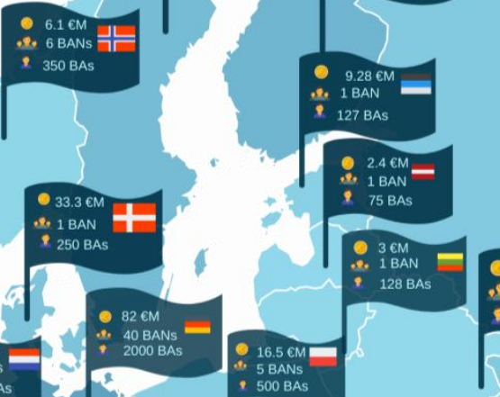
Based on European average data, business angels invest around 12.9% of total investments in FinTech companies (Dealroom data, 2019, EU):
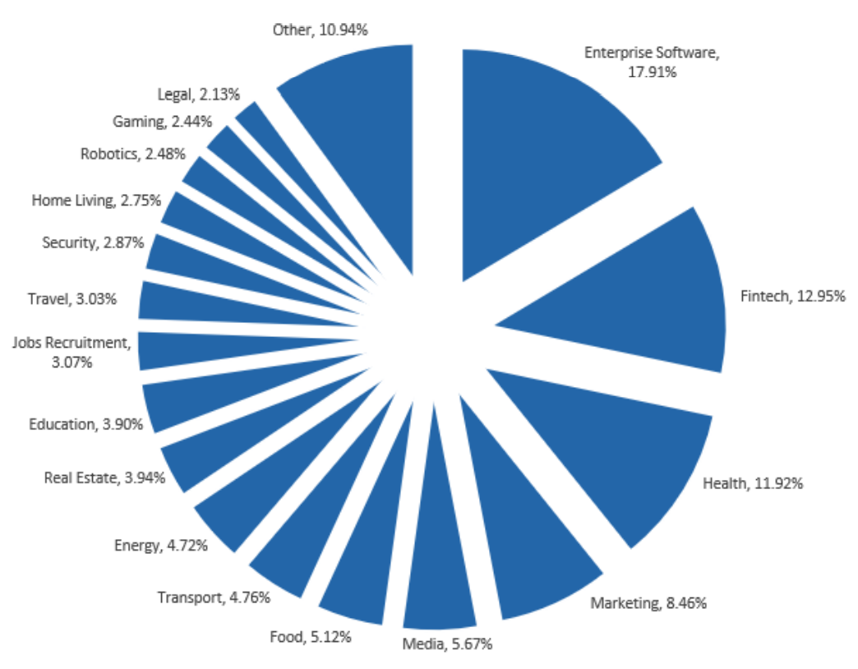 | Investments of business angels by the startup development stage and average amount per project:  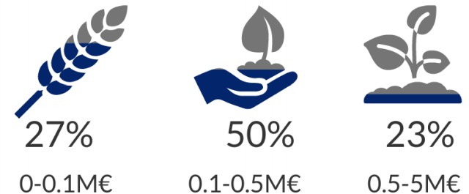  59% of business angels invest in companies with national capital, 9% invest at European level and 13% invest internationally.

The biggest challenges in investing in technology startups include:
- no proven market demand for the service - 76.3%;
- competition conditions not clarified - 66.9%;
- lack of competences to implement the project - 65.2%;
- no suitable team - 55.9%.
There are around 13 venture capital funds operating in Latvia, such as Change Ventures, Wise Guys Holding, Overkill Ventures, Capitalia. FinTech companies do not rank as a priority. Assessing the availability of private equity and venture capital (VC), it can be concluded that funding options are limited both at the early stage and during the growth stages.
Available capital and invested capital at the end of 2019, EUR million (Baltic states, all economic segments)
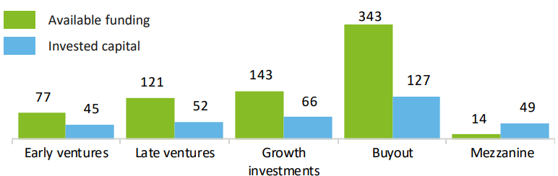
Venture capital funds in Estonia invest five times more in financial sector companies than in Latvia.
Latvia, end of 2019  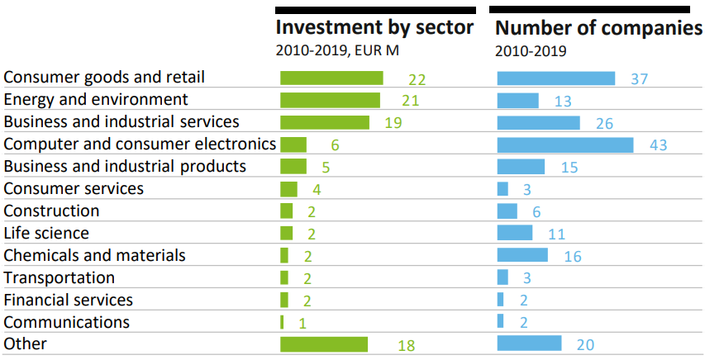 | Estonia, end of 2019  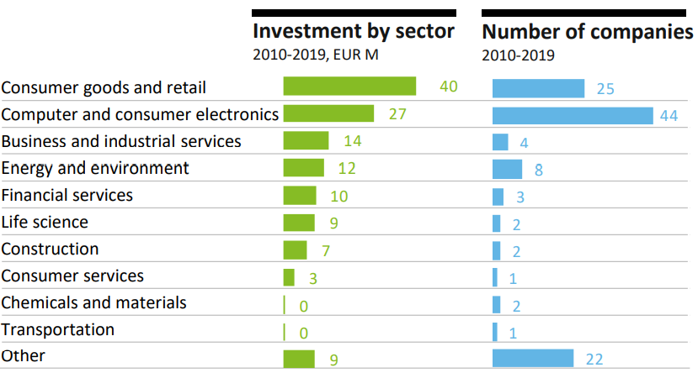
Currently, the licensing process is lengthy and requires a contribution of funds, as the paid-in share capital must be held in an account during this period. A shorter licensing process would also shorten the period during which these funds are “frozen”.
In the working group it was also highlighted that it is difficult for foreign funds to invest, as it is not always possible to prove the origin of the capital.
Branch representatives also point to deficiencies in the business angels environment, reducing the availability of capital even more, especially at an early stage (pre-seed to Series B). In general, there is a gap in the availability of funding during the period between the very early stage and the moment at which a company is ready for licensing.
It is necessary to assess to what extent the state aid programmes are available to financial institutions/financial service providers/FinTech, taking into account the restriction on financial services contained in the regulations. To achieve more certainty, it would be important to clearly define the financial services that are not eligible for the state aid, and to identify as far as possible the extent to which FinTech companies are eligible to receive the aid depending on the nature of the service provided, etc.
Innovation vouchers are mainly aimed at micro-enterprises and SMEs planning technology transfer, attraction of highly qualified staff, collaboration with research institutions at the EU level. FinTech is not listed among the sectors to be supported in the Cabinet Regulation governing this mechanisms (Cabinet Regulation No. 692), but FinTech companies can apply for aid in the fields of sectors to be supported.
FinTech companies have access to advisory support from LIAA, for example for participation in foreign events, partner attraction. There is also an option available to cooperate with the representative offices of LIAA and partner organisations. There are also individual aid options, for example, networking assistance, participation in events, etc.
In some cases, support from the International Finance Corporation (IFC) is also available. The main target audience is companies, Fintech startups and startups of other fields planning to implement projects in developing countries. Information events are organised on the possibilities of IFC support, and companies can apply upon their own initiative, as well.
In the working group, it was also pointed out to difficulties in VAT application to the so-called alternative financial services.
The Fund offers an Acceleration Programme for scientific startups. The minimum duration of the programme is three months. The business idea must be based on science or technology. The team must be represented by at least two people, one of whom is an entrepreneur with a business development role and the other one - a technology developer. The technology developer must take on the role of R&D Director and participate in certain accelerator activities.

Country image and communication
Focus of strategy and activities has a significant impact on the form, message content and target audience of marketing and communication events. It is important to define the technologically social focus - digitisation, advanced technologies, public good and/or sustainability, as well as the sector/product focus - payments, lenders, investments, crowdfunding or others.
Latvia does not currently have a single brand that can be used to promote FinTech direction. Magnetic Latvia brand will not be developed further. In developing the new country image strategy, LIAA has concluded that it is essential to change the perception of country image from a narrative about the current situation to a new direction with which the country would be associated, which is an internationally inspiring and engaging theme. Country image is therefore a direction that is reflected in the action policy and activities that take place in the country concerned. On 31 August 2021, the Cabinet of Ministers approved a report on Latvia's direction for its country image, which includes a mission approach and the implementation of the first pilot mission - the mission Sea 2030. This means that Latvia is shaping the development from a sustainability perspective - how to create new directions, inter alia, in the already-existing industries, so that the sea is no longer polluted. The scope of the theme provides for covering almost every sector, including FinTech, but it should not be one-way communication; it is necessary to create products that address sustainability issues in FinTech.
The cooperation institutions and associations recognise the positive changes in the FCMC's activities and are ready to include information about them in their communications, as far as this is relevant to their field of activity. However, in order to ensure a uniform and convincing communication, the FCMC would need to summarise and accordingly structure the benefits and changes.

Education and talent base
Talents drive embedding of innovation and the development of the financial sector is inseparable from the availability of IT professionals. Previously accumulated competences in the financial and IT sectors contributed to the digitisation of the sector. Despite FinTech being one of the fastest growing high value-added industries, for the time being the FinTech companies recognise that IT skills and resources are insufficient and do not meet the growing demand for knowledge in software engineering and finance.
Number of students in education subject groups (in thousands)  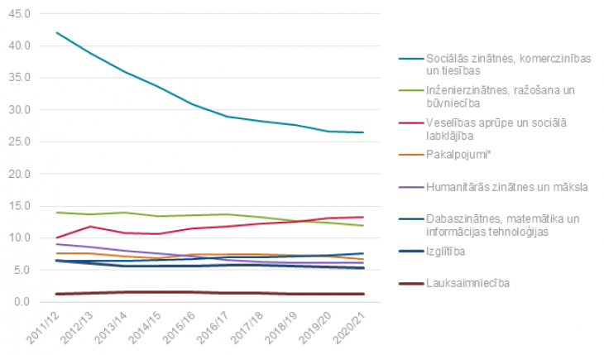  Social sciences, business and law  Engineering, manufacturing and construction  Healthcare and social welfare  Services*  Humanities and arts  Science, mathematics and information technology  Education  Agriculture | The number of enrolled students has reduced for the academic year 2020/2021; 78,500 students are studying higher education, with foreign students comprising 10% thereof.  There has been no growth observed in ICT.

In Lithuania, the situation is opposite: the number of graduates in the IT field is steadily increasing: In Lithuania, 1,301 professionals in IT and related disciplines graduated from higher education in 2017, 1,398 in 2018 and 1,522 in 2019.
According to DataStat.Gov.LV, the number of graduates in ICT is decreasing every year. Experts estimate that around 700 young professionals graduate in the field information technology every year, but this number falls far short of what is needed to fill vacancies in Latvian companies - at least 3,000 per year.

In addition, it is necessary to review the conformity of the education programmes (bachelors, masters) of higher education institutions to the skills of the future industry. For example, almost all European countries now have bachelor and master programmes of future technologies implemented in the field of AI. Branch representatives have pointed to shortcomings in the content of education at both higher and secondary education levels. Integration of financial and IT content into education programmes would be desirable, starting from the very basics to specialised programmes. To ensure the conformity of the educational content to labour market conditions, it is necessary to involve branch representatives and experts. The rapid development of technology also requires the periodic updating of programmes. The benefits of updating educational content are expected to extend beyond the FinTech sector, as the use of information technology is increasing in all sectors.
According to the forecasts expressed by the Ministry of Economy, the IT labour pool is expected to continue shrinking in the coming years, thus increasing the shortage of IT professionals and posing risks to future growth in the sector. By 2025, the shortage of highly qualified professionals in the exact sciences might grow to 17,000 working hands, even though the ICT sector is allegedly among the fastest growing sectors of national economy in Latvia with one of the highest remuneration levels.
Challenges in this area include the overall demographic situation - decline in the number of population and the forecasts of the Ministry of Economy (labour force forecasts to 2040) regarding the digitisation of the economy and the automation of jobs. According to the Ministry of Economy, the number of jobs in highly qualified occupations is expected to increase by around 80,000 by 2040 and account for more than half (52% or 461 thousand) of the total number of jobs in the national economy.
According to the DESI index indicator rating, Latvia is not only facing a gap in the number of IT professionals, but also in their qualification: both digital and software skills in Latvia lag behind the EU average. Latvia ranks 24th among EU countries in terms of human capital, and some indicators have fallen in recent years. Levels of basic and higher digital skills remain well below the EU average. Only 43% of the population aged 16 to 74 has at least basic digital skills (EU average - 58%) and only 24% has higher digital skills (EU average - 33%). The share of ICT professionals is also lower than the EU average (1.7% compared to 3.9%). However, the number of graduates with a degree in the IT field in Latvia is significantly higher than the EU average (5% in Latvia, 3.6% in the EU). By contrast, the share of female IT professionals in the labour force is well below the EU average (0.5% in Latvia, 1.4% in the EU).
 | Latvia |  |  | EU
 | DESI 2018 value | DESI 2019 value | DESI 2020  value | DESI 2020 value
2.a.1. At least basic digital skills | 48% | 48% | 43% | 58%
% individuals | 2017 | 2017 | 2019 | 2019
2.a.2. Above basic digital skills | 27% | 27% | 24% | 33%
% individuals | 2017 | 2017 | 2019 | 2019
2.a.3. At least basic digital content creation skills | 49% | 49% | 44% | 61%
56 individuals | 2017 | 2017 | 2019 | 2019
2.b.1. ICT specialists | 2.2% | 2.3% | 1.7% | 3.9%
56 of the total number of the employed | 2016 | 2017 | 2018 | 2018
2.b.2. Female ICT specialists | 1.1% | 1.0% | 0.5% | 1.4%
% number of employed women | 2016 | 2017 | 2018 | 2018
2.b.3. ICT graduates | 4.4% | 4.8% | 5.0% | 3.6%
% graduates | 2015 | 2016 | 2017 | 2017

Figure ‎1.2, Digital skills, DESI index, Latvia
Based on the referred to data, it can be concluded that the demand for IT specialists in the FinTech sector will remain high. It should be noted that current trends in the supply of talented professionals may also have a negative impact on the implementation of the National Development Plan Digital Transformation Guidelines for 2021-2027. The benefit of the Law on Aid for the Activities of Start-up Companies can be mentioned as a positive element: state aid of up to 45% for co-financing of highly qualified specialists.
Attracting experts from third countries is important for ensuring human resources. In the working group it was concluded that, while there is still room for improvement, in general, the legal framework is satisfactory (including the startup visa, the blue card framework. Branch representatives point out that speed and digitisation of processes are particularly important.
State aid is currently available in the form of training programmes for the employees of merchants. Employee training aimed at improving employee skills to implement technological innovations and increase labour productivity is available for micro, small, medium and large enterprises, covering 30%-70% of the costs. Aid for those employed in the financial sector is limited to those working in business service centres.
Additional training opportunities are available for startups, such as ICT, Non-Technology and Investor Attraction training.
LIKTA and LCCI organise training:
- on implementation of innovations (products, processes, marketing, organisational) at the request of merchants. Raising the qualification and skills of the employed in the ICT field for self-employed persons, micro, and small merchants (70% aid);
- Labour force of suitable qualification for implementing non-technological innovations for micro, small, large merchants (30%-50% aid).
LIAA organises Investor Attraction Training, where the funding is available for an investor for employee training for medium and large merchants (aid in the amount of 50-60% of costs).

Barriers to development of financial innovation
In 2021, the FCMC has implemented a number of initiatives to identify barriers to development of innovation in the financial sector:
- the FCMC Innovation Hub provided advice to existing and potential financial market participants;
- dialogues with FinTech industry representatives within the scope of the FinTech strategy (working in working groups with the Ministry of Finance);
- a survey of financial market participants conducted on the use of innovation;
- a survey of PI, EMI and the banks conducted on mutual cooperation;
- dialogues with the representatives of LMENA, LIAA organised;
- webinars organised for market participants in the fields of payment services and crowdfunding services.

Access to payment infrastructure
Latvia's payment infrastructure consists of systems and solutions that support the most popular payment instruments in Latvia - transfers or credit remittals and card payments, being the most popular means of payment among the Latvian population. Payment card infrastructure is available to licensed payment service providers through cooperation with the international payment card organisations VISA and MasterCard. For credit remittals in euro currency, payment service providers can choose from any of the many payment infrastructures in the SEPA, but the most popular are the EAS payment system of Latvijas Banka, private pan-European systems of the banking organisation EBA Clearing STEP2 and RT1 and the CENTROlink system of the Central Bank of Lithuania.
The infrastructure offered by Latvijas Banka is the most efficient (in terms of number of services and costs) among the above-mentioned systems (STEP2, RT1 and CENTROlink) and functionally the most extensive payment infrastructure in the euro area, offering credit transfers, including flash payments, in the EAS system, as well as a flash link service. It is planned that a flash request service will soon be available, not only for credit institutions but also for licensed electronic money and payment institutions, e-invoicing system operators and FinTech companies serving traders.
In dialogues with LMENA and PI/EMI branch representatives, there have been suggestions for the necessary changes in the accessibility of Latvijas Banka payment infrastructure, similar to how such solution operates in Lithuania. CENTROlink is a payment system enabling the performance of euro credit transfers in the SEPA, managed by the Central Bank of Lithuania. Through its infrastructure, the Central Bank of Lithuania provides credit institutions with direct access to the system, and the possibility for other payment service providers: credit unions, e-money or payment institutions licensed in the European Economic Area (EEA) to be accessible and send payments within the SEPA. The Central Bank of Lithuania provides a specific payment service (similar to correspondent relationships), with the Central Bank assuming the respective risks for these institutions, as for its own customers and for all payments made. This type of payment service is contributing to the fact that many European and also Latvian payment service providers prefer to obtain a licence in Lithuania.
Latvijas Banka notes that such a payment service is not a function of the central bank, namely, providing a specific payment service to a separate category of market participants when a similar service is already provided by market participants. No other euro area central bank has introduced such a payment service since 2017, when the Central Bank of Lithuania introduced it, indicating significant risks for the central bank. At the same time, such a service exposes the financial system to disproportionate reputational, money laundering and fraud risks. Latvijas Banka considers that the introduction of such a payment service is not economically justified and is associated with disproportionate risk assumption.
In addition, it should be noted that work is currently underway in the EU on amendments to the Settlement Finality Directive (SFD) that will facilitate the possibility of direct participation of licensed electronic money and payment institutions in payment systems, similar to what currently exists for credit institutions, where central banks would not have to assume significant additional risks.

Resource constraints
When commenting on the FCMC's 2021 Survey in the field of FinTech on barriers related to the implementation of solution, the respondents specified:

 |  |  |  | 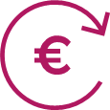
shortage of labour force and shortage of internal resources | legislative requirements | lack of high-quality IT specialists | IT resource attraction | increase in costs
Most of those participants who do not plan to implement FinTech solutions in the future pointed out the lack of financial resources as a key factor. For more details on the Survey results, see the FCMC website.
Having provided consultations at the Innovation Hub and received the questions from the participants, we can conclude that there is a lack of competence support in the segments: the law firms that provide advice are not always competent in FinTech issues, in particular in the fields of financial services regulation and AML/CTPF. Both consultants and bank representatives need to develop their competences in understanding the business models of FinTech companies.

Licensing process and requirements
In dialogues with industry and during individual consultations, applicants have pointed to shortcomings in the licensing process, including speed and requirements. Since July 2021, the FCMC has launched a comprehensive review of the licensing process for all market segments with the aim of making the process more predictable, faster and clearer.

State aid for FinTech companies and capital accessibility in the financial sector
Financial support is crucial for the development and registration of financial technologies in the Latvian market. Existing programmes for startups (Altum, LIAA) do not cover the development of services and products in the financial sector. This restricts development and forces companies to borrow in the alternative market at higher rates or raise capital outside Latvia, which in turn leads to companies registering in another country. These restrictions also affect the exportability of services and limit the scalability of business. According to the opinion of the industry (expressed in the 2021 FCMC Dialogue Working Groups), there is no access to venture capital funds in Latvia to finance FinTech companies at the stage of ideas and early stage before scaling. Funding is not available in the banking sector, either.

Talent base and access to human resources
Both in the survey and in the dialogues carried out by the FCMC, the industry representatives stress the lack of qualified specialists. Looking at the development and application of technologies in the field of data and artificial intelligence, in the direction of digital transformation, it has to be acknowledged that in Latvia, compared to Europe, there are (with the exception of a joint programme of the Transport and Telecommunication Institute and the University of the West of England) no specialised bachelor or master degree programmes available in artificial intelligence (compared to more than 100 specialised programmes available in Europe). Some courses have been developed by the RTU (Riga Technical University), Liepāja Technology Cluster.

Technology and infrastructure

Application of technology in the financial sector in Latvia
In spring of 2021, the FCMC, for the second year in a row, conducted a survey of Latvia’s financial and capital market participants to find out the scope and trends of innovative financial technologies used by them in Latvia.
182 market participants were invited to take part in the survey. Of these, 125 respondents answered the questions of the survey, 44 of whom indicated that they were already using some innovative solution for the provision of financial services solution; furthermore, 15 of them had a special team set up for the development and implementation of innovative solutions. 14 respondents plan to start using innovative financial technologies in the future.
In 2021, more market participants took part in the survey than before (69% in 2021 and 40% in 2020 of those invited). The share of market participants using certain innovative solution for financial services has increased by 1%.
Institutions, who provided services in 2021, by using FinTech solutions
Credit institutions, branches of foreign credit institutions in Latvia |  | Insurance companies, branches of Member State ICs in Latvia |  | Insurance brokers |  | Private pension funds
Investment management companies |  | Payment and electronic money institutions |  | Licensed alternative investment fund managers |  | Cooperative credit unions
The survey conducted by the FCMC reveals that four technologies are currently the most commonly used by market participants: application programming interface or API provisioning, contactless payments, biometric solutions and data cloud services.
Technologies used by financial and capital market participants
 | 26 |  |  | 17 |  |  | 16 |  |  | 14
 | Provision of API interfaces |  |  | Contactless payments |  |  | Biometric solutions |  |  | Services in data cloud
 | 6 |  |  | 5 |  | 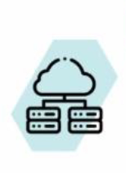 | 5 |  | 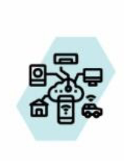 | 2
 | Artificial intelligence |  |  | Robo-consulting |  |  | Big data |  |  | Internet of Things
 | 1 |  |  | 1
 | Machine learning |  |  | Smart contracts
Compared to the previous year, the top most used technologies have changed, namely, in 2020, the most used FinTech solutions were as follows: strong authentication solutions (18 market participants), API provision (11), biometric solutions (11) and big data (9).
Over the year. a considerable increase in using the following FinTech solutions has been observed: API provisioning, biometric solutions, contactless payments and data cloud services.
In analysing the used innovative technologies by market segments, it can be seen that the credit institutions segment is the biggest user of innovative technologies - the most popular solution in this segment is the provisioning of APIs, which are mainly used by credit institutions for open collaboration platforms with FinTech companies. It is followed by the insurance sector, the representatives were the most frequent users of the following innovative technologies: API provisioning, data cloud services, biometric solutions, contactless payments and big data. Cooperative credit unions and licensed alternative investment fund managers were the ones to make the least use of the financial technologies. Investment brokerage firms, in turn, do not use FinTech solutions at all.
Innovative technologies used by market segment
Credit institutions, branches of foreign credit institutions in Latvia  Biometric solutions Artificial intelligence Contactless payments Services in data cloud Provision of API interfaces  Private pension funds  Biometric solutions Artificial intelligence Robo-consulting Big data Services in data cloud Provision of API interfaces  Payment institutions  Contactless payments Services in data cloud Provision of API interfaces  Electronic money institutions  Machine learning Contactless payments Services in data cloud Provision of API interfaces  Licensed alternative investment fund managers  Services in data cloud | Insurance companies, branches of Member State ICs in Latvia  Biometric solutions Artificial intelligence Robo-consulting Big data Smart contracts Contactless payments  Services in data cloud Internet of Things Provision of API interfaces  Insurance brokers  Biometric solutions Artificial intelligence Contactless payments Services in data cloud Internet of Things Provision of API interfaces  Investment management companies  Biometric solutions Robo-consulting Provision of API interfaces  Cooperative credit unions  Biometric solutions
15 market participants have set up a special team for the development and implementation of innovative solutions, namely seven credit institutions, two insurance companies and one market participant of EACH OF THE following: payment institution, an electronic money institution, a private pension fund, an insurance broker, an investment management company and an investment firm.
The survey conducted by the FCMC reveals that there are still two innovation directions observed in the financial and capital market of Latvia: one stems from market regulation (the Second Payment Services Directive, near-field communication or NFC, APIs), and the other is based on financial and capital market participants’ own initiative (biometric data, artificial intelligence, big data, robo-consulting, machine learning, etc.). The survey results indicate that market participants are planning to develop and implement the FinTech solutions of these two innovation directions over the next two years, with a particular focus on API provisioning, biometric solutions, big data, artificial intelligence and machine learning.
During the survey, market participants mentioned as obstacles for implementing a FinTech solution or successful operation, regulatory barriers such as regulatory compliance, legal restrictions, complex legal requirements, lack of experienced IT professionals in the market, as well as financial barriers such as limited financial resources and lack of investment.
The shortage of IT professionals and specialisation in innovative technologies is also reflected in the Technopolis Group study on the availability of resources in the AI field in the financial and banking sector in Europe:
Number of professionals with AI skills in Europe (2020)  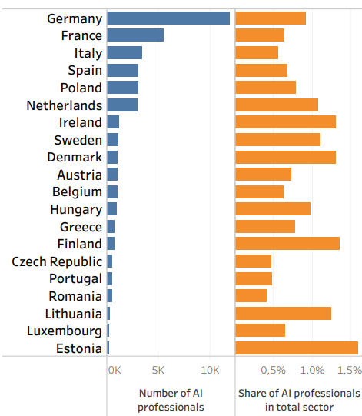 | Advanced technological skills, which showed the highest growth over the last year (2019-2020). Skills in AI, followed by the Internet of Things and blockchain. This result underlines the increase of digital technologies and digital skills in the financial and banking sector.  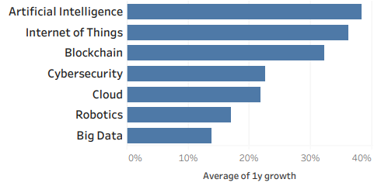

The European Commission has proposed a number of measures aimed at boosting excellence in the field of MI and rules that would help ensure trustworthy technologies. The Regulation on the EU Approach to AI and a review of the Coordinated Plan on Artificial Intelligence will guarantee the security and observance of fundamental rights of citizens and businesses, at the same time boosting investment and innovation in all EU countries. To this end, the European Commission will foster public - private partnership in the field of artificial intelligence, data and robotics to define, implement and invest in a common strategic research innovation and deployment agenda, and will create additional networks of AI excellence centres to foster the exchange of knowledge and expertise, develop collaboration with industry and foster diversity and inclusion.
Key AI policy objectives:
- Set enabling conditions for AI’s development and uptake;
- Build strategic leadership in high-impact sectors;
- Guarantee favourable conditions in the European Union for AI to strive;
- Ensure AI technologies work for people.

RegTech and SupTech development - technologies used in the supervisory work
In 2020, the FCMC completed the work on the development of a new data reporting system that adds functionality and improves the user experience. This system is an essential component of the common supervisory data receipt and processing solution. Supervisory data is critical for the performance of supervisory functions not only at the FCMC, but also at the EU centralised supervisory authorities to which the FCMC provides information. The FCMC not only ensures the receipt of processing of such data, but also provides a flexible possibility to market participants to select the data preparation method that is more convenient and beneficial for them. Such solutions are also known as SupTech or supervisory technology. They are expected to become increasingly important in the future.
In early 2021, the FCMC approved a RegTech and SupTech strategy (until 2025), which is currently being actively implemented. Supervisory methods are becoming more sophisticated every year, the volume of structured and unstructured data is increasing significantly, and the need for innovative technologies is growing. The purpose of the SupTech function of the FCMC is to make the supervisory process more efficient, modern and automated by applying new technologies. By improving the ICT literacy, the FCMC ensures compliance with future challenges and requirements. To reduce the need for labour resources, when using RPA technologies (robotic processes), automated data transfer processes were introduced in 2020, where all automated data quality checks have been performed.
Supervisory processes in the financial sector evolve in line with trends in financial markets and innovations in the field of information technologies. The priority directions of the FCMC's RegTech and SupTech strategy are text recognition and processing, advanced analytics and process automation. The introduction of new technologies will improve the efficiency of supervisory processes by providing market participants, in cooperation with the FCMC, with flexible and convenient cooperation solutions for information exchange and regulatory implementation.
The strategy builds on the dynamics of development of the systems resulting from the EU centralised decisions and supervisory models. New technologies, especially in the processing of unstructured data, will save time and expert resources in supervisory work. Identifying and applying the AI possibilities, in turn, will enable identifying such patterns, risks and challenges in the supervisory and regulatory process that are difficult to identify with human-assisted research methods.
In line with the SupTech strategy, already in 2021, the FCMC plans to streamline its monitoring processes by developing Network Analysis technology in the area of AML/CTPF, which enables the visualisation of a network of interconnected events or objects by mathematical analysis. This makes it possible to increase the value of the data by enriching its comprehensibility and interpretation. The improvement of financial market supervision and reporting, in turn, will be ensured by RPA technology, which performs pre-programmed, automated, repetitive actions in a single or middleware environment.

Assessment of the possibilities of PI/EMI to open a current account

General information
The Ministry of Finance in cooperation with Latvijas Banka and the FCMC, in accordance with Clause 2.2.1 of the Financial Sector Development Plan, has carried out an assessment to identify and remove obstacles and restrictions that limit the possibilities of PIs and EMIs to open a current account with a credit institution in order to fulfil the requirements of Section 38 of the Law on Payment Services and Electronic Money (hereinafter - LPSEM).
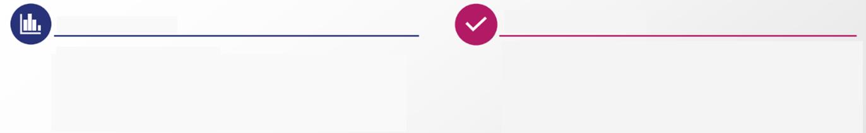
Number of EMI & PI
8
Number of EMI
-1
within 1 year
7
Number of PI
0
within 1 year
EMI - electronic money institutions
PI - payment institutions
EMI & PI licences

2
Number of licensed EMI
6
Number of registered EMI
5
Number of licensed PI
2
Number of registered PI
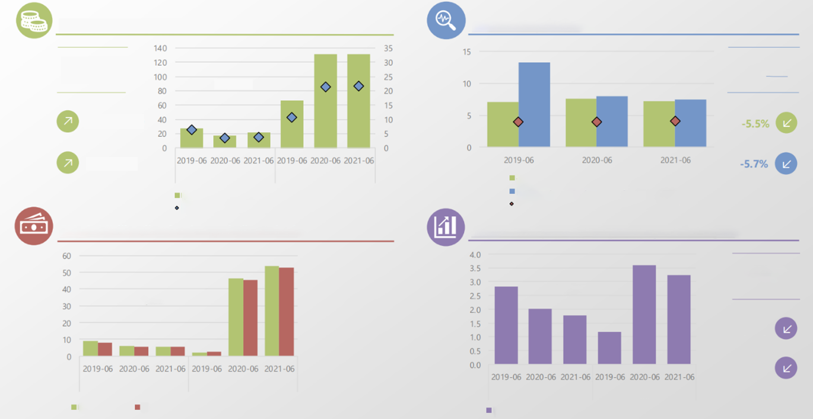
Payments with EMI & PI
E-money circulation (EMI)
Compared to 30 June 2020:
26.7% (EMI)
0.2% (PI)
million EUR
EMI
PI
Total amount of performed payments
Arithmetic value of payments made (right axis)
EMI & PI liquid assets and current liabilities
million EUR
Liquid assets > Current liabilities
EMI
PI
Liquid assets
Liabilities to service users
Gross revenue related to services rendered
EMI
PI
million EUR
Total amount of payments performed with e-money
Amount of redeemed e-money
Average amount of e-money in circulation
Compared to 30 June 2020:
EMI & PI revenue from rendering services
million EUR
Compared to 30 June 2020:
-11.8% (EMI)
-10.4% (Pl)

Figure ‎1.3, Latvian MI and ENI performance indicators for Q2 2021
In order to meet Clause 2.2.1 of the Financial Sector Development Plan (FSDP), the FCMC carried out a survey of PI, EMI and credit institutions regarding mutual cooperation among them (hereinafter - Survey). On the part of PI/EMI, 11 out of 15 respondents participated in the survey, while on the part of credit institutions - 13 out of 16 respondents.
In the Survey, PIs/EMIs mentioned the following as the key problems of cooperation with credit institutions:
- credit institutions are not familiar with the operational specificity of PIs/EMIs and perceive payment and electronic money institutions as competitors;
- credit institutions refuse to open current accounts for PIs/EMIs or their accounts are closed;
- credit institutions charge unreasonably high or inflated commissions;
- frequent, repeated and disproportionate information requests from credit institutions.
Credit institutions, in turn, when describing the key problems of cooperation, point out that:
- PIs/EMIs are not performing adequate ML/TPF risk management as regards customer identification and due diligence, determination of the origin of funds, inability or inadequate ability to manage risks with respect to servicing high-risk customers;
- both parties have different “risk appetites” and a different approach in the field of AML/CTPF and operational compliance.
In the Survey, credit institutions made a proposal to improve the internal control system of PIs and EMIs in the AML/CTPF field.
PIs/EMIs made the following proposals within the Survey:
- to improve the understanding of the credit institutions regarding the operation of PIs/EMIs to organise discussions between credit institutions and Pis and EMIs to foster cooperation; (The proposal is also supported by the Finance Latvia Association (FLA));
- release credit institutions from the responsibility for PI and EMI customer supervision.
During the Survey, respondents also made proposals on how the FCMC could facilitate the improvement of cooperation between credit institutions and PIs/EMIs:
- communicate with credit institutions on the application of risk-based approaches, develop guidelines for servicing PIs and EMIs using a simplified approach, organise training, seminars on the specificities of cooperation with payment and electronic money institutions;
- clearly agree upon the borders of liability and the proportionality of application of supervisory requirements, so that the credit institution does not have to invest disproportionate resources;
- explain the requirements under which a credit institution can be confident that it is managing the risk of servicing such customers;
- provide for a different (facilitated) approach in laws and regulations to the requirements for PIs and EMIs licensed in Latvia.

Summary and possible solutions
Considering the results of the Survey and the above mentioned, it is to be concluded that the regulatory enactments do not impose any obstacles limiting the possibility for PIs/EMIs to open a current account with a credit institution. The different understanding as to the fulfilment of the requirements of the AML/CTPF Law and cooperation risks caused by different or incomplete application of such requirements are to be mentioned as the most important problems of mutual cooperation between PIs/EMIs and credit institutions.
According to that which is specified in this assessment, the situation is to be addressed through the FCMC's dialogue with PIs/EMIs and credit institutions. Credit institutions, in turn, need to explain the application of risk-based approaches, as well as to develop guidelines for servicing PIs/EMIs using a simplified approach. In such a dialogue, it is necessary to clearly agree upon the borders of liability and the proportionality of application of supervisory requirements, so that the credit institution does not have to invest disproportionate resources, and to explain the requirements under which a credit institution can be confident that it is managing the risk of servicing such customers.
The process of revision of the Settlement Finality Directive might also be an alternative solution that would ensure that PIs/EMIs do not face problems opening current accounts with credit institutions in the future. In this process, it is intended to establish harmonised conditions in the Member States for the operation of PIs in payment systems, which could facilitate mutual understanding and cooperation between PIs/EMIs and credit institutions.

SWOT analysis
Internal factors
Strengths | Weaknesses
- Possibility to work in the EU market thanks to common regulation and supervisory practices;  - Easy to commence business, low barriers to commence operating in the ICT sector;  - High potential in lending SMEs as a type of service in the field of FinTech. | - Use of innovative technologies in the financial sector is lower compared to the EU;  - Low access to venture capital;  - FinTech companies are mainly outside the scope of the state aid programmes;  - A few examples of collaboration between FinTech and the banking sector;  - No access to payment infrastructure;  - Market fragmentation is increasing;  - Low culture in work with innovation;  - Slow licensing process.
External factors
Opportunities | Threats
- The regulation of artificial intelligence at EU level offers new opportunities for application;  - Develop AI and data solutions as a strategic direction, building on the EU AI strategy;  - Increase interest from both foreign investors in the FinTech sector and the Latvian population;  - Possibility of creating FinTech and state partnership in digitisation, ensuring competition;  - Technological impact of digital finance (provision of financial services by digital means), opportunities for the development of crypto-assets. | - Competition with Lithuania, Estonia and the UK from the point of view of company registration is growing;  - Possible competition from BigTech (Google, Apple, Amazon) in the field of financial services;  - Decrease of qualified labour force in the country and lack of ICT specialists in the innovative technology segment;  - Rising cyber-security risks in the financial sector.

Risks
 | Risks | Type of risk | Impact (low, moderate, significant) | Probability | Risk mitigation possibilities
1 | Regulatory requirements at EU level may increase | Legislative | Moderate | Moderate | Train employees, U TRAININGS for participants of the sector, involvement of external consultants, timely response to changes and regular follow-up on compliance
2 | Increase in cyber risks due to the introduction of new services | Human  Technical | Moderate | Moderate | Strengthen IT security supervisory measures
3 | Lack of human resources in the ICT segment and migration | Human | Significant | High | Increase the number of student places; ensure the attraction of foreign specialists
4 | National financial support will not be sufficient to implement the strategy | Financial and budgetary | Significant | Moderate | More actively develop private venture capital, cooperate with venture capital funds
5 | Uncertainties surrounding Covid-19 and its impact on investment volumes in the sector and economic development | Ecological, financial | Low | Low | IT and FinTech sectors continued to actively grow during the pandemic
6 | Limited access to capital may not have an accelerating effect on FinTech development | Financial and budgetary | Moderate | Moderate | More actively develop private venture capital and cooperate with venture capital funds
7 | Limited access to banking payment infrastructure | Technical | Moderate | Moderate | In the short term - to create a dialogue between payment and electronic money institutions and credit institutions, discussing topical issues relevant to the specificity of payment and electronic money institutions.  In the long term - work is currently underway in the European Union EU on the amendments to the Settlement Finality Directive that could facilitate the direct participation of licensed PIs and EMIs in payment systems, similar to the current situation for credit institutions.
8 | Inability of the organisations involved to implement the activities of the strategy | Human | Significant | moderate | set clear targets, deadlines; carry out monitoring on a regular basis

https://www.fktk.lv/licencesana/inovacijas-un-fintech/
https://www.mk.gov.lv/sites/mk/files/media_file/kk-valdibas-deklaracija_red-gala-1.pdf
https://www.businessinsider.com/ai-in-banking-report
https://www.fktk.lv/licencesana/inovacijas-un-fintech/
Section 1 of the Law on Freedom of Information
Sectoral Watch Report - European Commission
LIAA Presentation ICT industry in Latvia, July 2021
Swedbank FinTech Report 2020
https://www.bvef.lu.lv/par-mums/zinas/zina/t/61396/
UL FinTech Sector Study
The Survey conducted by the FCMC in 2021 “Summary of the Survey of PIs/EMIs and Banks on Mutual Cooperation”
FCMC Annual Statement of 2020
https://latvia.dealroom.co/lists/19839/
Data on volume of transactions from the website https://p2pmarketdata.com/p2p-lending-funding-volume-eu/
https://p2pmarketdata.com/p2p-lending-funding-volume-eu/
REPORT ON CONSUMER (NONBANK) LENDING MARKET ACTIVITY IN THE FIRST HALF OF 2021, https://www.ptac.gov.lv/lv/media/2620/download
https://lvportals.lv/norises/329670-nebanku-kreditesana-strauji-saruk-naudas-atmazgasanas-risks-zems-2021
https://latvia.dealroom.co/lists/19839/
https://sunfinance.group/
https://www.ptac.gov.lv/lv/media/116/download, page 35
https://latvia.dealroom.co/lists/19839/
https://www.pwc.com/gx/en/services/legal/tech/assets/estonia-the-digital-republic-secured-by-blockchain.pdf
https://latvia.dealroom.co/lists/19839/
https://likta.lv/nozare-skaitlos/
https://ec.europa.eu/info/publications/180308-action-plan-fintech_en
Please see more detailed information in the FCMC's Explanatory Note on the possibilities of using virtual assets (crypto-assets) and initial coin offering (hereinafter also referred to as ICO) and the applicable regulation. The Explanatory Note provides information on the possible applications and uses of ICs, the applicable ICO regulation and information for ICO organisers and investors, and explains the terms used. https://www. fktk.lv/jaunumi/pazinojumi-medijiem/fktk-izstradajusi-skaidrojumu-par-virtualo-aktivu-un-ico-izmantosanas-iespejam-un-piemerojamo-regulejumu/
https://ec.europa.eu/info/law/better-regulation/have-your-say/initiatives/12090-Finansu-pakalpojumi-noturibas-pret-kiberuzbrukumiem-uzlabosana-jauni-noteikumi-_lv
https://www.fktk.lv/jaunumi/svarigi/fktk-inovaciju-laboratorija-pieredzes-stasts/
https://www.openbankingtracker.com/country/latvia
Swedbank FinTech Report 2020
GatewayPartners 2019 Startup Ecosystem Study.
https://startuplatvia.eu/files/resources/resource_file/LIAA%20Startup%2016.03%20.pdf
https://digital-strategy.ec.europa.eu/en/policies/desi-latvia
https://digital-strategy.ec.europa.eu/en/policies/desi-latvia
https://digital-strategy.ec.europa.eu/en/policies/desi-latvia
https://dealroom.co/blog/how-europes-biggest-investment-category-is-faring-in-2020
Finstar techEU study “The state of fintech in Europe, January 2021”
Finstar techEU study “The state of fintech in Europe, January 2021”
https://www.delfi.lv/bizness/bankas_un_finanses/velas-veicinat-finansu-sektora-konkuretspeju-un-digitalo-attistibu.d?id=52635153
https://www.venturefaculty.io/news/new-latvian-fintech-landscape-pusblished-at-dealroom-co
EBAN statistics compendium, European early states market statistics 2019
Deloitte, Baltics Private Equity and Venture Capital Market overview 2010-2019
Deloitte, Baltics Private Equity and Venture Capital Market overview 2010-2019
https://labsoflatvia.com/atbalsts#attistiba/starptautiska-finansu-korporacija-sfk
https://www.altum.lv/lv/pakalpojumi/riska-kapitals/
https://lvportals.lv/dienaskartiba/324191-krities-studejoso-un-uznemto-studentu-skaits-2021
https://www.tvnet.lv/7231245/baltija-trukst-it-darbinieku-latvija-ar-atalgojumu-it-specialistiem-izkonkurejusi-igauniju
https://data.stat.gov.lv/pxweb/lv/OSP_PUB/START__IZG__IG__IGA/IGA040/table/tableViewLayout1/
https://bismart.lv/blogs/vieda-valsts/it-nozares-attistibu-varetu-veicinat-arzemju-studenti-1348
https://www.workingday.lv/sagatavotas-latvijas-darba-tirgus-prognozes-lidz-2040-gadam
https://digital-strategy.ec.europa.eu/en/policies/desi-latvia
https://www.fktk.lv/licencesana/inovacijas-un-fintech/
https://www.bachelorsportal.com/ un https://www.mastersportal.com/
Technopolis Group based on LinkedIn analysis, 2020
Technopolis Group based on LinkedIn analysis, 2020
https://ec.europa.eu/info/strategy/priorities-2019-2024/europe-fit-digital-age/excellence-trust-artificial-intelligence_en

