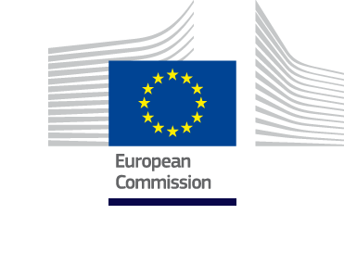

ANNEX C1bis: Twinning Light Fiche

Project title: Support to enhance the organisation and governance of the Institute, strengthen its capacity for data collection, epidemiological analysis and monitoring, and improve its emergency response for communicable diseases and cross-national threats

Beneficiary administration: Institute of Public Health, Tirana, Albania

Twinning Reference: AL 20 IPA HE 01 21 TWL

Publication notice reference: Prospect reference code: 172817

EU funded project
TWINNING TOOL

Abbreviations

ACP African, Caribbean and Pacific States
AL Albania

CEI Central European Initiative

CFCU Central Finance and Contracting Unit
DEIDC Department of Epidemiology and Infectious Disease Control

EU European Union

HE Health and Consumer Protection

IPA Instrument for Pre-Accession Assistance

IPH Institute of Public Health

JRC Joint Research Centre

Labs Laboratories

MHSP Ministry of Health and Social Protection

MS Member State

MTBP Medium-Term Budget Planning

PAO Programme Administration Office

PHC Primary Health Care Services

PL Project Leader

SDGs Sustainable Development Goals

SEEHN South East European Health Network

STIs Sexually Transmitted Infections

TAIEX Technical Assistance and Information Exchange

TWL Twinning Light

UK United Kingdom

UN United Nations

WHO World Health Organization

- Basic Information

  - Programme: IPA (II), Action Programme for Albania IPA 2020/ 042-914.03/AL/EU Integration Facility (indirect management, with ex-ante control)

For UK applicants: Please be aware that following the entry into force of the EU-UK Withdrawal Agreement on 1 February 2020 and in particular Articles 127(6), 137 and 138, the references to natural or legal persons residing or established in a Member State of the European Union and to goods originating from an eligible country, as defined under Regulation (EU) No 236/2014 and Annex IV of the ACP-EU Partnership Agreement, are to be understood as including natural or legal persons residing or established in, and to goods originating from, the United Kingdom . Those persons and goods are therefore eligible under this call.

1.2 Twinning Sector: Health and consumer protection (HE).

1.3 EU funded budget: EUR 250,000.

1.4 Sustainable Development Goals (SDGs): SDG 3 - Ensure healthy lives and promote well-being for all at all ages.

2. Objective

2.1 Overall objective:

To support Albania in improving its ability to recognise and respond to public health emergencies, including serious public health threats of cross-border relevance.

2.2 Specific objective:

The epidemiological surveillance system of communicable diseases in Albania is strengthened in line with EU acquis, EU standards and International Health Regulations.

The prevention, monitoring, reporting management system and capacities on communicable diseases in public and private laboratories, clinics and hospitals in Albania are improved in line with EU acquis.

2.3 The elements targeted in strategic documents i.e. National Development Plan/Cooperation agreement/Association Agreement/Sector reform strategy and related Action Plans

The strategic framework for public health is based on three national strategies, the strategies we currently rely on and which include monitoring all components of public health, including epidemiological surveillance of infectious diseases (see below):
- Albanian National Health Strategy 2016-2020 (Although this document is formally limited to
5 years, the strategy projects the basic objectives of improving health care for the next decade, i.e. until 2025) and budgeted Action Plan. The National Health Strategy 2021-2025 is currently being drafted and is a continuation of the previous Strategy 2015-2020, oriented towards the promotion of healthy living and prevention of diseases, especially infectious diseases.
IPH, DEIDC through the National Sector of Infectious Diseases Surveillance as the National
Coordination Centre for Infectious Diseases Surveillance collects, processes, analyzes in time and continuously the data on infectious diseases, sent to the IPH by the Epidemiological Services throughout country (partly electronic information system) and intervenes or acts on the basis of this data. Currently, there are several epidemiological surveillance systems for monitoring infectious diseases (ALERT, Monthly Report Sheet, Influenza and Respiratory Infections, Sexually Transmitted Diseases, Epidemic Outbreaks, etc...).Reporting of infectious diseases is mandatory by law based on Law no. 15/2016 on the Prevention and Control of Infections and Infectious Diseases.
Also, the Draft Strategy is based on evidence that underlies the priorities, objectives and actions to achieve the vision (health for all) and the mission (to protect, improve and promote the health, productivity and well-being of all people in Albania, ensuring efficient health and medical services and ensuring sustainable progress in public health and medicine).
- Primary Health Care Services Development Strategy in Albania 2020-2025.
The Primary Health Care Services Development Strategy in Albania 2020-2025 envisages the
provision of integrated health care, quality, accessible and affordable for the whole community at the right time. This strategy includes the objective of expanding the range of free services offered to all citizens, thereby promoting universal health service coverage. It aims to create new service models to cover the needs that have been identified at the community level, such as the prevention and control of non-communicable diseases, the family care service for the elderly, models of care through digital technology, especially in remote areas, providing public health, etc.
This strategy will ensure better access of vulnerable communities to health care services in fulfilment of the long-term objective, that of universal coverage.
- Public Health Strategy and Health Promotion 2011-2021. The strategy responds to
Albania’s public health challenges, but also uses the strengths of the health system of the country and seeks to preserve its positive aspects. A major effort will be needed to prevent current trends from making the health experience of Albanians worse, and it will take an even greater effort to make improvements.
The strategy is modelled on the WHO European regional strategy for Health for all in the 21st Century. The strategy outlines the various component policy areas that collectively contribute towards population health, and provides the rationale for engagement and analysis of the current situation and trends in Albania.

In response to the COVID-19 outbreak, the Albanian Ministry of Health and Social Protection adopted a decision (Law no. 23-2020) on health surveillance and other measures to prevent the transmission of the disease. A national coordination body was established to coordinate the national response to the pandemic and take adequate precautionary measures. These included a nationwide curfew, social distancing, a ban on public gatherings and public religious ceremonies, and a country-wide lockdown during weekends at the most critical days. Self-isolation and quarantine periods were imposed initially on people arriving from affected countries and subsequently to all individuals identified at epidemiological risk. Albania has been associated to the work of the EU Health Security Committee, and received material from the EU Joint Research Centre (JRC) to control COVID tests.
Furthermore, the following priorities identified for the health sector under the National Plan for European Integration 2021-2023 are of specific relevance for this project:
- Improve infectious disease surveillance and response programmes through improving legislation, capacity building, digitalisation of information networks, and upgrading of public health microbiology laboratories.
- Improve pandemic preparedness and response and other disease control policies (HIV/AIDS, Syphilis, Viral Hepatitis, Influenza, Immunization programme, etc.) by increasing capacities and improving national strategies.

3. Description

3.1 Background and justification:

The health system in Albania is mainly public. The state is the leading provider of health services, health promotion and prevention, and the diagnosis and treatment of diseases. The private sector, which is still developing, covers most pharmaceutical and dental services, private hospitals and some highly specialized diagnostic clinics, mainly in Tirana and some other large cities in Albania. The Ministry of Health and Social Protection (MHSP) is responsible for the development and planning of health policies and the implementation of health strategies whereas, the Institute of Public Health (IPH), as a National Centre in the field of public health, is responsible for the development and application of disease prevention and the control (through surveillance systems) of injuries, disabilities, environmental health detrimental factors, and the development and application of health promotion, in close cooperation with national and international agencies / bodies / organizations. The diagnostic and curative health service in Albania is organized at three levels: primary health care, secondary hospital service and tertiary hospital service. Public health services provided for primary health care are coordinated and supervised by the MHSP and IPH. Primary health care services (PHC) at the local and regional level represent the first level of access to health care by giving high priority to hygiene, the epidemiological situation and the needs of the population at territorial level for health services. Public health is a duty of the government and is organised at central and territorial level based on Law No.10 138, dated 11.5.2009 on Public Health. The organisation and structure of public health at national level is based on the administrative division into 12 regions and 61 municipalities. Public health institutions including the Institute of Public Health (IPH) and the Health Care Service Operators are institutions subordinated to the Ministry of Health and Social Protection. Their activity extends not only at central level but also regionally (according to the new administrative division) with their respective directorates. The total number of employess in the system oh Health Care Service Operators is 220 employees.

The Albania 2020 Report issued by the European Commission on 5 October 2020 states that “In the field of serious cross-border health threats including communicable diseases, the legal basis for communicable disease prevention and control is designed to be in line with the EU acquis. However, it still needs to be implemented through secondary legislation. Albania has a national alert, response and surveillance system for communicable diseases. However, no national plan for implementing international health regulations. It still does not have an antimicrobial resistance action plan”.

The Albanian system of epidemiological surveillance for infectious diseases is mandatory and dates from the 1950s. The Law No. 15/2016 on “Preventing and Fighting Infections and Infectious Diseases” prescribes that the infectious diseases included in this system must be reported.

Currently in Albania, the information flow on infectious diseases is released through a monthly reporting form (named-14/Sh), compiled by the epidemiological service at health district level and sent to the Department of Epidemiology and Control of Infectious Diseases at the IPH. It is highlighted that the content of the monthly reporting form has hardly changed over time, thereby reflecting the fact that the mandatory reporting of infectious diseases from the epidemiological services of the district continues to be based on passive epidemiological surveillance. The data through the monthly form of these diseases have been reported as a case number. The -14/Sh reporting form aggregates data according to age-group and by districts as well. These data have no scientific value because they are not associated with the data at individual level. The quantitative and qualitative improvement of information flow on the infectious diseases in Albania is an urgent necessity. This mainly relates to the restructuring of the monthly reporting form (-14/Sh) and the individual epidemiologic forms of infectious diseases which shall ensure active epidemiological surveillance in addition to the passive routine. This will also require the widespread application of sentinel epidemiological surveillance. Sentinel Surveillance is established for some diseases such as Influenza, but it should be strengthened for other infections for example for the detection of HIV and other STIs among high-risk groups.

The ALERT system of reporting infectious diseases system has been jointly implemented by the IPH and the WHO since 2000, creating an effective early warning system for infectious diseases in Albania. The "ALERT" system is based on syndromes (syndromic Surveillance), from General Practitioners and emergency services at the hospital level including the weekly compulsory notification of nine specific infectious syndromes, namely: diarrhoea without blood, diarrhoea with blood, upper respiratory infection, lower respiratory infection, rash with fever, jaundice, haemorrhage with fever, suspected meningitis, and unexplained fever. The data flow structure of the ALERT system implies weekly mandatory notification from the basic level (data sources) to the national level (Department of Epidemiology of Infectious Diseases of the IPH) of the surveillance system through the local level (epidemiological services at district level).
Critical issues for the surveillance of infectious diseases (infection tracking) include low quality in data collection (incomplete, slow and inaccurate); organisational issues (information flows are not well defined) and a need to improve the system to achieve the standards required by the European Centre of Diseases Control.

To improve the surveillance and tracking of the infection, the following measures are required:
- Improving the performance of microbiological laboratories thereby allowing a more accurate assessment of the etiologic of diseases (starting with forms of hepatitis).
- Creating a new notification form, that is more simplified and easier to complete.
- Simplification of information flows, identification of district reference points that collect data from various structures (including private ones) in the area.
- Introduction of electronic systems that allow for the acceleration of data transmission from the peripheral nodes of the network (circular references) to the Institute of Public Health.
- Training for public health operators.
- Strengthening the reporting system involving not only the public sector but the private sector as well.

Based on the Law of Infectious Diseases (2016) and on the experience of COVID-19, it is crucial to include and to strengthen the reporting system of Infectious Diseases from the private sector (Private Labs, private clinics and hospitals), strengthen the Active Surveillance System (through the training of field epidemiologists) and increase the involvement of General Practitioners in the surveillance of Infectious Diseases.

3.2 Ongoing reforms:

Health in all policies is a concept and practice of governance, which includes raising the awareness of representatives of different sectors of government on the impact on the health of the population and their pro-active role in policy formulation and action for health. The Government of Albania and the Ministry of Health and Social Protection recognise the importance of this concept to address health inequalities and ensure better health and well-being for all citizens of Albania. These cross-sectoral efforts have been implemented through joint policies and actions between the health, social protection and environmental protection sectors, especially for the protection and promotion of health.

The Ministry of Health and Social Protection is constantly cooperating with the World Health Organization (WHO) and other United Nations Agencies. The World Bank is also making a significant contribution in support of the reform in the sector, both with technical assistance and support for capital investments. In the field of Public Health, with the support of the World Bank, projects are being implemented such as:
"Additional Financing to the Health System Improvement Project"
The objective of the Project is to contribute to the modernization of selected public hospital services.

“Albania Emergency COVID-19 Response Project”
The objectives of the Project are to prevent, detect, and respond to the threat posed by COVID-19 and strengthen national systems for public health preparedness in the Republic of Albania.

In addition to multilateral cooperation, bilateral cooperation is also contributing to the improvement of the health system in Albania through a number of projects such as the EU-funded project implemented by WHO on “Strengthening health systems resilience in the Western Balkans (Albania, Bosnia and Herzegovina, Kosovo* Montenegro, North Macedonia, and Serbia)” March / 2021. One of the strategic objectives of this project was "Strengthening and maintaining all-hazard preparedness and response capacities across the Western Balkans region". The components of this project were:
- Providing technical assistance to the 6 Western Balkans partners for the development and costing and / or updating plans on all-hazard preparedness and response, and one Health
- Supporting the development in each IPA beneficiary of Standard Operating Procedures (SOPs) to support all-hazard preparedness and response.
- Supporting the operationalization, implementation and testing of all-hazard preparedness and response plans in all participating Western Balkans IPA beneficiaries through the development of their capacities to organize simulation exercises to identify, review and exchange best practices between the 6 IPA beneficiaries
- Supporting the development of capacities and of relevant guidelines and SOPs to strengthen and maintain routine and emergency capacities at points of entry (e.g. airports, ports).
- Providing support to establish, maintain and strengthen quality assured regional laboratory networks for emergency preparedness and response through regional capacity building and knowledge exchange, as well as training of competent IPA beneficiary staff on laboratory capacity assessment tools
- Organization of regional training on all hazard risk assessment, profiling and mapping including biological, chemical, radiological, nuclear and natural hazards

In addition, the Ministry of Health and Social Protection actively participates and contributes to regional cooperation in health, through the South East European Health Network, SEEHN, and the implementation of bilateral and multilateral agreements, which complement the WHO, UN and EU programmes. The focus of international and regional cooperation will continue to be on issues of global importance, which have a special impact in the region and the country, such as humanitarian crises, immigration, natural disasters, climate change, cross-border risks, etc. The National Plan for European Integration includes medium and long-term measures, until 2023, with the aim of fully aligning the national legislation of all sectors with the EU acquis.
Albania also took the initiative in 2014 to reform local government in an effort to achieve a real and necessary decentralization after several previous non-radical reforms. Cross-cutting Strategy for Decentralization and Local Government (SKNDQV) was approved by the Council of Ministers in 2015, and was revised in 2018, setting out the objectives of the decentralization process in Albania. Regarding the function of ‘social services’, this objective of this law was the distribution of economic aid and the provision of social services in municipalities within a smaller number of municipalities, especially when the legal basis for this sector refers to 2005 before the reform.

3.3 Linked activities:

In the framework of infectious disease monitoring, the IPH has benefited from projects supported by WHO consisting of the training of specialists in the field at the local and central level.

Funding from EU institutions has addressed the establishment of the ALERT surveillance system with the support of the Italian National Institute of Health (Istituto Superiore di Sanità, Rome).

The IPH has a Memorandum of Understanding with the Istituto Superiore di Sanità through which it has carried out a series of EU-supported TAIEX activities on public health emergency management. The IPH has also implemented projects financially supported by the Central European Initiative (CEI) with a focus on Improving Disaster Risk Reduction skills and Resilience-building capacities in the Western Balkans: EMS Web and Distance Learning on epidemic and pandemic outbreaks in Western Balkans. This collaboration has consisted of a series of activities focusing on infectious diseases as well as inter-laboratory collaboration, and included an assessment focusing on mapping the equipment in Public Microbiology Laboratories in Albania, and microbiology diagnostic system quality in the function of surveillance. In this context, Ministry of Health and Social Protection has benefited from a modification of IPA 2017 National Programme in supporting the fight against the pandemic Covid-19. As part of this support, 4 million Euro have been provided to Albanian authorities to buy medical equipment.

Moreover, the IPH is one of the Beneficiaries of the project HAP - Health for All, Albania - Phase 2, financed by the Swiss Cooperation. Since 2015, the Health for All Project (HAP), funded by the Swiss Agency for Development and Cooperation (SDC) and implemented by a consortium led by Swiss Tropical and the Swiss Institute of Public Health (Swiss TPH), Terre des hommes and Save the Children, is working closely with the Ministry of Health, the Institute of Public Health, primary health care officials, family physicians to promote public health in Dibra and Fier regions. The project aims to help the population of these two countries, especially vulnerable groups, to benefit from better health through improved primary health care service and health promotion activities through:
- Strengthening Health Care Management: providing training to further develop management capacity, strengthening and making the primary health care service more efficient.
- Infrastructure Improvement: rehabilitating infrastructure and providing basic equipment for better use and functioning of primary health care centers.
- Promoting Social Inclusion: strengthening capacity in health promotion and disease prevention for civil society organizations and communities, to ensure that service recipients are better informed about health issues.
- Increase transparency and accountability: by implementing transparency mechanisms, accountability tools and anti-corruption strategies to improve the quality of care in a way that focuses on the patient.
- Continuing Medical Education (EVM): providing activities for EVM to enhance the skills of healthcare workers.

As part of the European integration process, Albania is stepping up its efforts to use the TAIEX and IPA assistance mechanisms to strengthen capacities of the health institutions. The future EU support to the health sector under formulation may help in the years to come, among the others, the implementation of the ‘Roadmap to implement the TWL strategic recommendations and improve preparedness and response to pandemics and other infectious diseases’ that shall be prepared under Component 3 of this Twinning light project. This in complementarity with the ongoing regional initiatives.

3.4 List of applicable Union acquis/standards:

Several EU Decisions and Regulations regulate communicable diseases. Most relevant for this project are the following ones:

- Commission Implementing Decision 2018/945 of 22 June 2018 on the communicable diseases and related special health issues to be covered by epidemiological surveillance as well as relevant case definitions.

- 2014/504/EU: Commission Implementing Decision of 25 July 2014 implementing Decision
- No 1082/2013/EU of the European Parliament and of the Council with regard to the template for providing the information on preparedness and response planning in relation to serious cross-border threats to health (notified under document C (2014) 5180.

- Decision No 1082/2013/EU of the European Parliament and of the Council of 22 October 2013 on serious cross-border threats to health and repealing Decision No 2119/98/EC.

An extended list is provided under Annex 5.

3.5 Components and results per component:

Component 1:
Legal, regulatory and institutional framework on the prevention and control of communicable enhanced.
Result 1.1 - Legal framework reviewed in view of further alignment with EU benchmarks.
Result 1.2. - Recommendations for improvement proposed.

Component 2: The epidemiological surveillance system capacity strengthened.
Result 2.1. - Epidemiological surveillance system capacity related to infectious disease surveillance is assessed against EU standards.
Sub-Result 2.1.1 - Recommendations for its improvement through digitalisation of information networks are made.
Result 2.2. - Gaps in the level of comprehensiveness and modernisation of epidemiological surveillance systems detected
Sub-result 2.2.1 - Capacity to collect manage and process data and information on communicable diseases strengthened.

Component 3: Enhanced health human resources capacities involved in preparedness and response to epidemic and pandemic situations and other communicable diseases.
Result 3. - Improved educational framework for health human resources, in line with reviewed national strategies and response plans.

  - Expected activities:

The information provided in the table below is only indicative and the list of activities is the minimum to achieve the mandatory results. The MS are strongly recommended to propose additional activities and a different outline if necessary, regarding number of man days.

Activities | Months (x = man-days) |  |  |  |  |  |  |  | Man-days
 | 1 | 2 | 3 | 4 | 5 | 6 | 7 | 8
 | Coordination and Visibility
Kick off meeting.  Project Steering Committee meetings.  Project management and reporting.  Final Event.  Preparation of communication and visibility outputs for the web/social networks. |  |  |  |  |  |  |  |  | 3  3  3  2  3
Component 1 | Legal, regulatory and institutional framework on the prevention and control of communicable enhanced.
Activity 1.1  Development of a gap analysis between the national legislation and the European one in view of alignment with EU acquis. |  |  |  |  |  |  |  |  | 29
Activity 1.2 Development of a methodology to assess the Governance on prevention and control systems for communicable diseases in line with EU standards. |  |  |  |  |  |  |  |  | 25
Component 2 | The epidemiological surveillance system capacity strengthened.
Activity 2.1  Adapt, from pre-existing methodologies successfully implemented in the Balkan Region, the assessment methodology to implement the indicator framework and thresholds set in Albania  Sub-Activity 2.1.1  Adapt a GAP questionnaire and evaluation platform, identify responding stakeholders, and define a Roadmap for data collection and validation. |  |  |  |  |  |  |  |  | 30
Activity 2.2  Gap Assessment of current microbiology laboratory capacities and practices in the public sector in all the domains in line with EU case definition (Pilot Study on Distance learning on epidemic and pandemic outbreaks in Western Balkans: Albania, Bosnia & Herzegovina, Montenegro, North Macedonia, Serbia)  Sub-activity 2.2.1  Production of a report on the identified gaps of current microbiology laboratory capacities and practices in the public and private sector, and corresponding recommendations including on sub-national level. |  |  |  |  |  |  |  |  | 35
Activity 2.3. Two Workshops to discuss, validate initial findings, and facilitate positions on the TWL recommendations:  Sub Activity 2.3.1  Workshop to discuss the results of the gap assessment in national and subnational public microbiology laboratories in order to determine the needs and increase the surveillance systems of infectious diseases according to the standards of required.  Sub Activity 2.3.2: Workshop with health professionals from National Reference Laboratories with a specific focus on the organisation and implementation of an effective external quality system for microbiology laboratories in line with EU standards and requirements. |  |  |  |  |  |  |  |  | 18
Activity 2.4  Formulation of a strategy for the digitalisation of the system for monitoring and reporting on communicable diseases, in line with EU case definition, including cost estimates. |  |  |  |  |  |  |  |  | 30
Component 3 | Enhanced health human resources capacities involved in preparedness and response to epidemic and pandemic situations and other communicable diseases.
Activity 3.1. Drafting a Roadmap to implement the TWL strategic recommendations and improve preparedness and the response to pandemics and other infectious diseases, agreed with national public health system stakeholders. |  |  |  |  |  |  |  |  | 25
Activity 3.2  Preparation of a Professional Development Program and Manual as part of the university curriculum to increase the capacity of health human resources in the management of infectious disease surveillance systems and emergency response to communicable diseases and international and cross-national threats. |  |  |  |  |  |  |  |  | 30
Closing conference |  |  |  |  |  |  |  |  | 4
1-8 Months |  |  |  |  |  |  |  |  | 240

3.7 Means/input from the EU Member State Partner Administration:

The Member States proposals must contain a fully elaborated work plan with the detail of all activities, including specific objective, content, duration, sequence, indicators, a communication and visibility plan, etc. It also should provide a budget breakdown per budget heading and sub-headings based on the flat rates, unit costs as well as on reimbursable expenditures.
Member State must submit their proposals individually (no consortia are allowed). Nevertheless, experts from other Member State can be included in the work plan. In this case, they would contribute to the project under the authority and responsibility of the Member State PL.

No form of sub-contracting to the private sector is allowed, with the only exception of the hiring of translation and interpretation services, where necessary.

The Twinning Partners shall ensure the visibility of EU financial assistance throughout the duration of the twinning project. Compliance will be ensured with the provisions of the document ‘Communication and Visibility in EU-financed external actions”, available at:
https://ec.europa.eu/europeaid/sites/devco/files/communication-visibility-requirements-2018_en.pdf

Proposals shall include the CV of the proposed PL, the Component Leaders and Short-term experts.

Profile and tasks of the Project Leader (PL):

The project is envisaged to provide exchange of experience and know-how with a Member State homologue Institution with good practice in the above stated project activities.
This project requires a Project Leader who will be responsible for the overall coordination of the project activities. The project leader is expected to closely work with the short-term experts as well as with the counterpart of the beneficiary institution (IHP)

Profile:
- University degree or equivalent professional experience of 8 years in the field of Medicine and specifically Public Health targeted by the Twinning Project.
- High ranking official from a Member State homologue institution (Proven contractual relation to a public administration or mandated body);
- At least 3 years of professional experience in the public health area (assessment and treatment of public health risks, communicable diseases, epidemiologist, public health statistician);
- Previous experience in international project management shall be an asset;
- Computer literacy;
- Excellent knowledge of written and spoken English.

Tasks:
- Overall coordination of the Project in cooperation with Component Leaders and short-term
Experts;
- Regular communication with the Beneficiary, the EU Delegation to Albania and the Contracting Authority;
- Participation in Steering Committee meetings;
- Participate in quarterly meetings of the Project Steering Committee with the Beneficiary Country PL;
- Project reporting;
- Project financial management, visibility and backstopping services for the project in the Member State;
- Overall responsibility and direction of the Member State Twinning partner input and proposal of corrective measures if needed, provision of strategic advice regarding the implementation of the Twinning Project, and ensuring that the project produces the required outputs successfully and efficiently and achieves the intended results on time;
- Participate in preparation of the initial and subsequent work plans;
- Prepare and sign the interim and final reports.

3.7.1 Profile and tasks of Component Leaders:

The Member State Twinning partner will appoint Component Leaders who will be responsible for delivering the results/outputs for specific components. The IPH will also identify Component Leader counterparts.

Profile:
- University degree or equivalent professional experience of 8 years in the field of Medicine and specifically Public Health targeted by the Twinning Project;
- Professional experience of at least 3 years in the relevant area of the specific component. (assessment and treatment of public health risks, communicable diseases, epidemiologist, public health statistician);
- Experience in training and mentoring in at least one project in the fields relevant to the project shall be considered as asset;
- Excellent knowledge of written and spoken English;
- Computer literacy.

Tasks:
- Undertaking all activities and achieving mandatory results;
- Conducting analysis on the area of the project components;
- Preparing and conducting the training programme;
- Elaborating and presenting the proposals on the area of the project components.

3.7.2. Profile and tasks of other short-term experts:

The proposed short-term experts are expected to cover the relevant areas and tasks targeted under this project. Short-term experts will cover and provide advice and know-how in the areas covered by this twinning project.

Profile:
- University degree or equivalent professional experience of at least 8 years;
- Minimum 3 years of specific professional experience in specific fields (assessment and treatment of public health risk, medical, epidemiologist, public health statistician and infectious disease doctor) targeted by this Twinning Project;
- Excellent knowledge of written and spoken English;
- Computer literacy.

Tasks:
- Undertaking all activities and achieving mandatory results;
- Conducting analysis and reports on the area of the project components;
- Preparing and conducting training sessions/workshops;
- Elaborating and presenting the proposals on the area of the project components.

4. Budget

The budget for the project is EUR 250,000, which will be covered by the IPA contribution, in line with the Twinning Manual.

5. Implementation Arrangements

5.1 Implementing Agency responsible for tendering, contracting and accounting (AO/CFCU/PAO/European Union Delegation/Office):

General Directorate for Financing and Contracting of EU, World Bank and Other Donor Funds/ (CFCU)
Ms. Veronika Korkaj, General Director
Ministry of Finance and Economy, Third floor (CFCU’s protocol office),
Bulevardi Deshmoret e Kombit, No. 3
1001 Tirana, Albania
Email: veronika.korkaj@financa.gov.al

Delegation of the European Union to Albania
Mrs. Alessandra Frontoni
Email: Alessandra.FRONTONI@eeas.europa.eu
The Project Manager at the EU Delegation

5.2 Institutional framework

The Ministry of Health and Social Protection of Albania has the mission of guaranteeing the constitutional rights to social protection and inclusion and social care and equal opportunities. The Institute of Public Health (IPH) is a National Centre in the field of public health under the Ministry of Health and Social Protection, whose mission is to design and implement development policies and strategies in the health care sector. It is responsible for regulating health care services and coordinating work between all actors inside and outside the health care system, thus also aiming and contributing to guarantee the constitutional right defined in Article 55 of the Constitution of the Republic of Albania. Its functions comprise the development and application of prevention and control of diseases, injuries, disabilities and environment factors detrimental for health, and the development and application of health promotion, in close cooperation with national and international agencies / bodies / organisations. The IPH coordinates operations for disease control and prevention of infectious diseases and the implementation of the International Health Regulations.

The IPH’s remit encompasses the following responsibilities:
- Monitoring the health condition of the population in order to identify in time and scientifically solve the health problems encountered.
- Identifying and monitoring health risk determinants.
- Undertaking and increasing the level of information of the population, its education and awareness on health problems.
- Stimulating, coordinating and supporting the initiatives of institutions and communities in terms of activities undertaken by them to identify and solve health problems.
- Prompting and supporting new legislation and regulations aimed at protecting the health of the population and its health insurance.
- Continuous training, education and professional support of public health workers.
- Evaluating the effectiveness, accessibility and quality of both population-based and patient-based health services.
- Conducting research to provide innovative solutions to health problems as well as to establish effective strategies on disease control and prevention.

The departments that will be involved in the realization of the project are as follows.
- Department of Risk Assessment and Treatment of Public Health Risks (13 – Epidemiologist, Hygienist, Operators and Public Health Specialist).
- Department of Epidemiology and Infectious Disease Control (38 - Public Health Specialist, Operators, Public Health Statistician and Epidemiologist).
- Department of Epidemiology and Health Systems (5 – Public Health Specialist).
- Department of Health Information, Technology and Communication (3 – specialist in information technology (IT) use, computers software, networks, servers).

In each department is included no. of public health specialists who will be part of the work in achieving the objective of the TWL project.

The IPH will be the beneficiary administration of this Twinning Project. This project will include the departments of Epidemiology and Infectious Disease Control, Risk Assessment and Treatment in Public Health, and Department of Epidemiology and Health Systems. The structure of each Department is presented in Annexes 2, 3 and 4. The number of staff who will benefit from this action is around 100.

The three above-mentioned departments exercise their activity in close scientific cooperation with all the relevant health institutions in the country such as the University Hospital Centre "Mother Teresa" and the Health Care Service Operator which is established as a state institution, and operates according to the definitions of organisation and direction established under the Decision of the Council of Ministers No. 419 dated 04.07.2019. The Health Care System Operator is articulated in 4 Regional Directorates of Health Care Service and 36 branches of Health Care Units throughout Albania. The Health Care Units performs functions of the Institute of Public Health at territorial level.
The IPH is a National Reference Centre, which organises and implements national and international research and projects in the field of diagnosis and control of infectious diseases.

5.3 Counterparts in the Beneficiary administration:

5.3.1 Contact person:

Ms. Elida MATAJ, PhD. MSc. MPH. MD,
Head of the Environmental Epidemiology,
Department of Risk Assessment and Treatment of Public Health Risks,
National Institute of Public Health,
Address: Street “Aleksandër Moisiu” No. 80, Tirana, Albania.
E-mail: Elida.Mataj@ishp.gov.al , elidamata@yahoo.com

5.3.2 PL counterpart

Ms. Elida MATAJ, PhD. MSc. MPH. MD,
Head of the Environmental Epidemiology,
Department of Risk Assessment and Treatment of Public Health Risks,
National Institute of Public Health,
Address: Street “Aleksandër Moisiu” No. 80, Tirana, Albania.
E-mail: Elida.Mataj@ishp.gov.al , elidamata@yahoo.com

6. Duration of the project

The implementation period of the Action is 8 (eight) months. The execution period of the contract shall end three months after the implementation period of the Action. (11 months)

7. Sustainability

Since the overall objective of the Twinning Light is to ‘To strengthen the epidemiological surveillance system of communicable diseases in Albania in line with EU acquis, EU standards and International Health Regulations, in order to recognise and respond to public health emergencies, including serious public health threats of cross-border relevance’, the project is expected to have a long term impact on preventing the cross-border transmission of communicable diseases through a better functioning surveillance system. A crucial element for sustainability of the project is to prepare the ground for the enhancement of the educational system linked to the project.

By identifying the needs and implementable interventions that will allow the strengthening of the overall National Surveillance System for communicable diseases in Albania, the Twinning Light will pave the way for improvement of the surveillance system on communicable diseases and for further sustainable development of the institutional capacities necessary to respond to serious health threats of cross-border relevance, thus contributing to boosting resilience and preventing the emergence and spread of future health crises. The project shall therefore also contribute to achieve UN Sustainable Development Goal 3 “Ensure healthy lives and promote well-being for all at all ages” underpinned by 13 targets.

The Ministry of Health and Social Protection prepares its budget through the Medium-Term Budget Planning (MTBP) mechanism. For 2020, the budget includes 7 budget lines accounting for around 512 million EUR (around 19.86% of the total annual budget). The IPH is included in the MTBP and has planned the necessary resources for ensuring the sustainability of the twinning light project in the period 2021-2023.

8. Crosscutting issues (equal opportunity, environment, climate etc…)

All activities within this project shall be designed and implemented in accordance with the principles of good governance, the protection of human rights, gender equality and environmental sustainability.

8.1 Equal Opportunities

The project will be implemented according to the regulations of the national legislation providing equal opportunities for men and women and non-discrimination on the basis of racial or ethnic original, religion or belief, disability, sex or sexual orientation or any other grounds. Twinning partners are expected to comply with the EU equal opportunity policies.

8.2 Environmental and Climate Considerations

The digitalisation of the National Surveillance System for Communicable Diseases of Albania shall reduce travel and the use of paper. The project shall use remote meeting facilities whenever appropriate, also aiming to reduce travel associated carbon emissions.

In the context of Component 2, the review of the Laboratory quality system shall also include an assessment of the management of waste and energy efficiency and measures to improve the current practices and performance.

9. Conditionality and sequencing

9.1 Conditionality

This project is not dependent on the outcomes of other actions. During its design, proper consideration has been given to actions/activities/events planned under the TAIEX tool that are of direct relevance for the sector.

The Beneficiary furthermore shall:

- Ensure that appropriate staff is made available to work with the EU twinning partner(s). Counterparts for each of the objectives will be appointed to facilitate the implementation of the respective activities of the twinning project.
- Be responsible for providing the EU experts with legislation and any other documents necessary for the implementation of the project.
- Ensure that staff trained under this project is encouraged to increase its capacity according to the tasks specified in the job description and to its promotion based on the merit. In this context a data base of what training was provided to which person should be maintained by the implementing partner for future monitoring.
- Provide all possible assistance to solve any unpredictable problem/situation that the EU twinning partner(s) may face during the time the project continues.

Equally, the Twinning team must ensure full collaboration with the counterparts of the institution. Communications should be open and consistent. The Twinning team must carry out activities in the interest of the institution, and maintain its involvement at all stages of activities.

9.2 Sequencing
Keys milestones will be:
- Successful selection of a Twinning partner
- Signature of the Twinning contract, including the Twinning Work Plan;
- Start of the twinning partnership;
- End of the implementation period;
- Submission of the final report.

10. Indicators for performance measurement

The indicators included under the log frame matrix are selected for measurement of the project’s achievements.

Component 1:
Indicator: Status of harmonization of the legislation with EU legislation and best practice.

Activity indicator 1.1 and 1.2: Number of working documents produced in support to the approximated legislation.

Component 2:
Indicator: Level of comprehensiveness of a proposed digitalised system for monitoring and reporting on communicable diseases, in line with EU case definition, including cost estimates.

Activity indicator 2.1: Level of comprehensiveness of proposed methodology for gap analysis of current microbiology laboratory capacities and practices in the public sector, in line with EU standards.

Activity indicator 2.2: Status of identification of current gaps in microbiology laboratory capacities and practices in the public sector.

Activity indicator 2.3: Number of stakeholders involved in discussion and decision making related to the improvement of infectious disease surveillance system.

Component 3:
Indicator: Extent to which a Professional Development Programme and manual for health human resources to improve the infection disease surveillance system and emergency response for communicable diseases and cross-national threats could be prepared, together with National Authorities.

Activity indicator 3.1: Extent to which a roadmap to implement the TWL strategic recommendations and improve preparedness and the response to pandemics and other infectious diseases could be prepared, in consultation with national public health system stakeholders.

Activity indicator 3.2: Number of stakeholders involved in discussing the draft Roadmap.

11. Facilities available

The Institute of Public Health shall host the experts of the Member State and the planned activities by making available office space, meeting rooms, equipment and software as well as opportunities and facilities for training, seminars and conferences.

____________________________
21Commission Implementing Decision (EU) 2018/945 of 22 June 2018 on the communicable diseases and related special health issues to be covered by epidemiological surveillance as well as relevant case definitions.

ANNEXES TO PROJECT FICHE
1. Simplified Logical Framework Matrix
2. Organisational Chart of the IPH’s Department of Risk Assessment and Treatment of Public Health Risks
3. Organisational Chart of the IPH’s Department of Epidemiology and Infectious Disease Control
4. Organisational Chart of the IPH’s Department of Epidemiology and Health Systems
5. Legislation on Public Health and Infectious Diseases – Albania and List of relevant EU Decisions and Regulations.
6. Existing donor coordination framework and sector’s monitoring framework
Annex 1. Simplified Logical Framework Matrix
Objectives, Results and Activities | Description | Indicators (with relevant baseline and target data) |  | Sources of verification |  | Risks |  | Assumptions (external to project)
Overall Objective | To support Albania in improving its ability to recognise and respond to public health emergencies, including serious public health threats of cross-border relevance. | Baseline:  EC Progress Report on Albania 2020, October 2020.  Indicator:  Progress made towards meeting accession criteria under Chapter 28 (public health). |  | EC Progress Reports on Albania. |  | Reduced focus of the government on development of sustainable institutions capacities due to the commitment in managing the situation caused by COVID-19 pandemic outbreak |  | Strengthening the surveillance system on communicable diseases in line with EU acquis and EU standards remains a political priority.
Specific (Project) Objective(s) | The epidemiological surveillance system of communicable diseases in Albania is strengthened in line with EU acquis, EU standards and International Health Regulations.  The prevention, monitoring, reporting management system and capacities on communicable diseases in public and private laboratories, clinics and hospitals in Albania are improved in line with EU acquis | Baseline:  Draft National Health Strategy 2015-2020.  Indicator:  Policy and strategic documents approved by the Ministry of Public Health and the Government of Albania, reflecting planned improvements, and implementing secondary legislation in place. |  | TWL final report. |  | Insufficient institutional coordination between health authorities and other authorities in charge with management of public emergencies. |  | 1. Institutional coordination is in place.  2. Political consensus on the strategic importance of the public health system and the need to improve preparedness and response to the pandemic and outbreaks of other contagious diseases  3. Stakeholders engagement in the TWL project activities
Component 1 – Legal, regulatory and institutional framework on the prevention and control of communicable enhanced.
Result 1.1 Legal framework reviewed in view of further alignment with EU benchmarks.  Result 1.2 Recommendations for improvement proposed. | Enhanced legal framework on prevention and control of communicable diseases. | Baseline:  Law 15/2016; Law 23/2020, Emergency legislation adopted to deal with the COVID-19; National Health Strategy 2015-2020; various actions plan, emergency and contingency plans related to communicable diseases.  Indicators:  Component 1 Indicator: Status of harmonization of the legislation with EU legislation and best practice.  Activity indicator 1.1 and 1.2: Number of working documents produced in support to the approximated legislation. |  | -TWL final report.  -National Plan for European Integration 2022-2024.  -EC Progress Reports on Chapter 28.  -Minutes of meetings of  - Stabilization and Association Council,  - Stabilization and Association Committee, any relevant Stabilization and Association Agreement Sub-Committee (e.g.  SAA Subcommittee on internal market and competition, including consumer & health protection. |  | Limited willingness of relevant stakeholders and decision-makers to discuss the reform and contribute to improving the TWL recommendations. |  | Relevant stakeholders and decision-makers are willing to discuss the recommended improvements and associated reforms.
Component 2 – The epidemiological surveillance system capacity strengthened.
Result 2.1. - Epidemiological surveillance system capacity related to infectious disease surveillance is assessed against EU standards.  Sub-Result 2.1.1 - Recommendations for its improvement through digitalisation of information networks are made.  Result 2.2. - Gaps in the level of comprehensiveness and modernisation of epidemiological surveillance systems detected  Sub-result 2.2.1 - Capacity to collect manage and process data and information on communicable diseases strengthened. | Gaps in the level of comprehensiveness and modernisation of epidemiological surveillance systems are detected in order to strengthen the capacity to collect manage and process data and information on communicable diseases. | Baseline:  Final report of the project ‘Distance learning on epidemic and pandemic outbreaks in Western Balkans: Albania, Bosnia & Herzegovina, Montenegro, North Macedonia, Serbia’ financially supported by the Central European Initiative, April 2021.  Indicators:  Component 2 Indicator: Level of comprehensiveness of a proposed digitalised system for monitoring and reporting on communicable diseases, in line with EU case definition, including cost estimates.  Activity indicator 2.1: Level of comprehensiveness of proposed methodology for gap analysis of current microbiology laboratory capacities and practices in the public sector, in line with EU standards.  Activity indicator 2.2: Status of identification of current gaps in microbiology laboratory capacities and practices in the public sector.  Activity indicator 2.3: Number of stakeholders involved in discussion and decision making related to the improvement of infectious disease surveillance system. |  | TWL final report. |  | Lack of willingness of the private sector organisations to take part in project’s activities. |  | Relevant documentation available.  Willingness of staff in laboratories to provide the required data through online surveys.  Feasibility of performing site visits to selected Health Care Service Operators, Microbiology Laboratories, and National Reference Laboratories.  Workshops organized through remote modalities (if necessary)  CVO active collaboration to the workshop.
Component 3 - Enhanced health human resources capacities involved in preparedness and response to epidemic and pandemic situations and other communicable diseases.
Result 3. - Improved educational framework for health human resources, in line with reviewed national strategies and response plans. | Educational Framework improved for health human resources. |  | Baseline:  National Health Strategy 2015-2020. Various actions plan, emergency and contingency plans related to communicable diseases.  Indicators:  - Component 3 Indicator: Extent to which a Professional Development Programme and manual for health human resources to improve the infection disease surveillance system and emergency response for communicable diseases and cross-national threats could be prepared, together with National Authorities.  Activity indicator 3.1: Extent to which a roadmap to implement the TWL strategic recommendations and improve preparedness and the response to pandemics and other infectious diseases could be prepared, in consultation with national public health system stakeholders.  Activity indicator 3.2: Number of stakeholders involved in discussing the draft Roadmap. |  | TWL final report.  -National Plan for European Integration 2022-2024.  -EC Progress Reports on Chapter 28.  -Minutes of meetings of  - Stabilisation and Association Council,  - Stabilisation and Association Committee, any relevant Stabilisation and Association Agreement Sub-Committee (e.g.  SAA Subcommittee internal market and competition, including consumer & health protection. |  | Lack of institutional coordination delays the discussion on the roadmap. |  | The roadmap prepared by the TWL partners includes the identification of sufficient resources (staff, technical, financial) that can be mobilised for its implementation.
Activities | Description
Component 1 | Activity 1.1: Development of a gap analysis between the national legislation and the European one in view of alignment with EU acquis.  Activity 1.2: Development of a methodology to assess the Governance on prevention and control systems for communicable diseases in line with EU standards.
Component 2 | Activity 2.1: Adapt, from pre-existing methodologies successfully implemented in the Balkan Region, the assessment methodology to implement the indicator framework and thresholds set in Albania.  Sub-Activity 2.1.1: Adapt a GAP questionnaire and evaluation platform, identify responding stakeholders, and define a Roadmap for data collection and validation.  Activity 2.2: Gap Assessment of current microbiology laboratory capacities and practices in the public sector in all the domains in line with EU case definition (Pilot Study on Distance learning on epidemic and pandemic outbreaks in Western Balkans: Albania, Bosnia & Herzegovina, Montenegro, North Macedonia, Serbia).  Sub-activity 2.2.1: Production of a report on the identified gaps of current microbiology laboratory capacities and practices in the public and private sector, and corresponding recommendations including on sub-national level.  Activity 2.3.: Two Workshops to discuss, validate initial findings, and facilitate positions on the TWL recommendations.  Sub Activity 2.3.1: Workshop to discuss the results of the gap assessment in national and subnational public microbiology laboratories in order to determine the needs and increase the surveillance systems of infectious diseases according to the standards of required.  Sub Activity 2.3.2: Workshop with health professionals from National Reference Laboratories with a specific focus on the organisation and implementation of an effective external quality system for microbiology laboratories in line with EU standards and requirements.  Activity 2.4: Formulation of a strategy for the digitalisation of the system for monitoring and reporting on communicable diseases, in line with EU case definition, including cost estimates.
Component 3 | Activity 3.1: Drafting a Roadmap to implement the TWL strategic recommendations and improve preparedness and the response to pandemics and other infectious diseases, agreed with national public health system stakeholders.  Activity 3.2: Preparation of a Professional Development Program and Manual as part of the university curriculum to increase the capacity of health human resources in the management of infectious disease surveillance systems and emergency response to communicable diseases and international and cross-national threats.
Horizontal Activities  (Remote or in-person) | Kick-off meeting.  Project Steering Committee meetings.  Project management and reporting.  Final Event.  Preparation of communication and visibility outputs for the web/social networks.

Annex 2. Organisational Chart of the IPH’s Department of Risk Assessment and Treatment of Public Health Risks

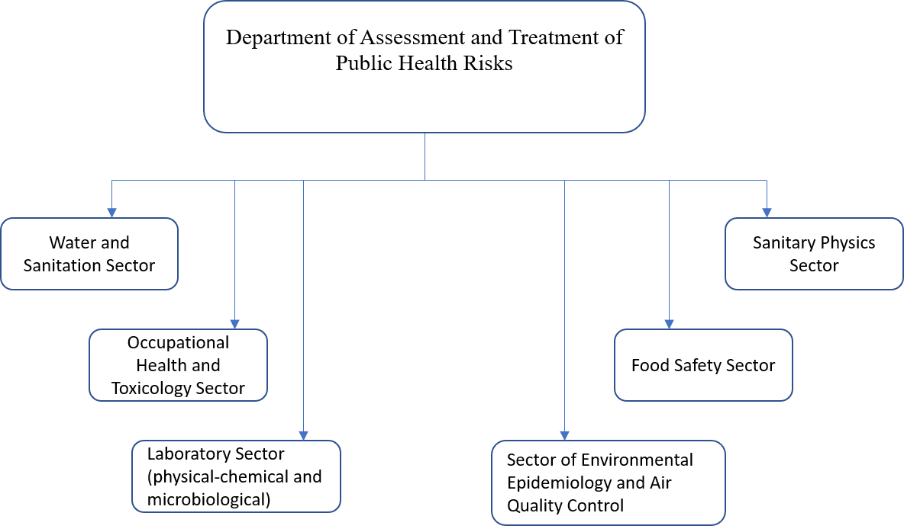
Annex 3. Organisational Chart of the IPH’s Department of Epidemiology and Infectious Disease Control

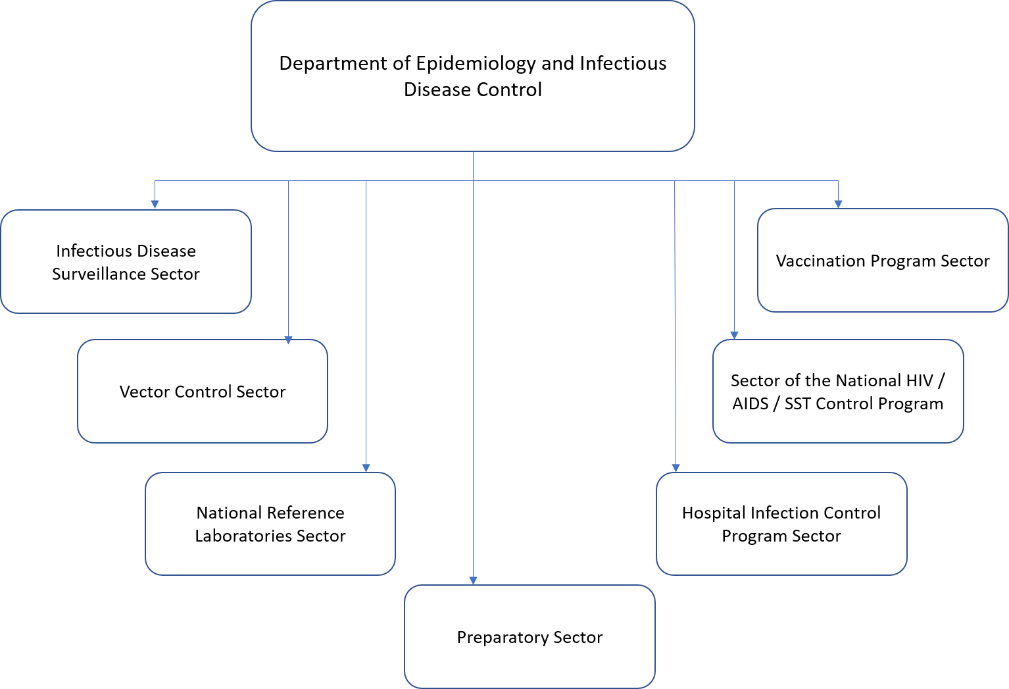

Annex 4. Organisational Chart of the IPH’s Department of Epidemiology and Health Systems

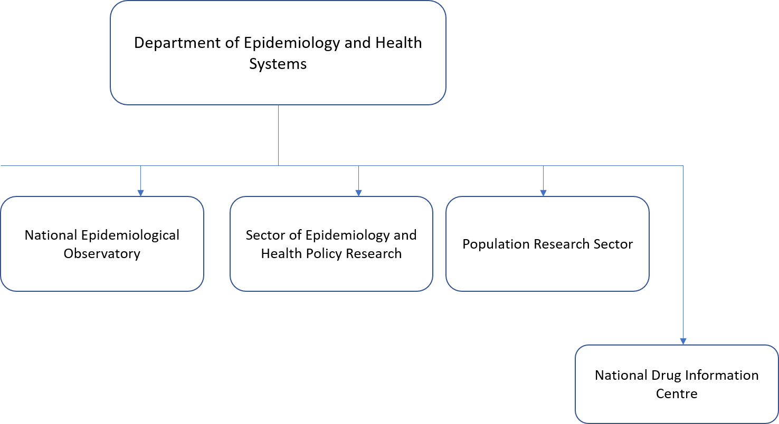
Annex 5. Legislation on Public Health and Infectious Diseases – Albania and List of relevant EU Decisions and Regulations.

National Legislation

- Law No. 15/2016 on “Preventing and fighting infections and Infectious Diseases’ in order to protect the population from infections and infectious diseases, defines the rules and activities for their timely detection, identification, prevention and control, for the elimination and eradication of morbidity and mortality from these diseases.
- Law No. 7761 of 19/10/1993 “On fighting and prevention of infectious diseases” amended in 1999 covers widely all of the problems of infectious diseases in the field of fighting and prevention of them by causes. In the first chapter, articles 1-8 are describe their group, organs and structures that cover the areas of fighting and prevention of infectious diseases, and the specialisation required to the employees. In the second chapter, Articles 9-22 describe the fighting measures of the infectious diseases, financing and modalities of their announcement. In the third chapter, the set of measures for immunisation of the population, types of vaccine, vaccination calendar and determining of type of vaccine and their import are prescribed, which are the obligation of Ministry of Health and National Immunisation Committee.
- Law No. 7643 of 02/12/1992 “On Public health and the State Sanitary Inspectorate” amended in 1995 and 2006 stipulates the organisation of the Sanitary State Inspectorate structure, and the problems and fields covered by this organism which is a vertical structure organised into regional and district level near the Public Health Directories. This structure has a monitoring and controlling function on all of the activities carried out by public and private entities in the country that may affect human health by air, land and waters.
- Law No. 10138 of 05/11/2009 “On Public Health” aims to ensure health protection and promotion of healthy living through organised activities by public health structures. This is an "Umbrella" law summarising in detail the legal documents in the field of public health, purpose, main definitions and basic principles of public health.
- Law No. 10107 of 30/03/2009 “On Health Care” defines the essential principles, legal framework and regulations that apply the public and private entities which operate in the health care system.
- Law No. 9952 of 14/07/2008 “On Prevention and Control of HIV/AIDS” repeals the 2000 law and is focused on the setting of measures for the prevention and control of this diseases in Albania.

EU Decisions and Regulations

Implementing Measures Early Warning and Response System
2000/57/EC: Commission Decision of 22 December 1999 on the early warning and response system for the prevention and control of communicable diseases under Decision No 2119/98/EC of the European Parliament and of the Council. - Official Journal, L 21/32; 26.01.2000
2017/253/EU: Commission Implementing Decision of 13 February 2017 laying down procedures for the notification of alerts as part of the early warning and response system established in relation to serious cross-border threats to health and for the information exchange, consultation and coordination of responses to such threats pursuant to Decision No 1082/2013/EU of the European Parliament and of the Council

List of communicable diseases
2018/945/EU: Commission Implementing Decision of 22 June 2018 on the communicable diseases and related special health issues to be covered by epidemiological surveillance as well as relevant case definitions

Case definitions for reporting communicable diseases
Commission Decision No 2009/363/EC of 31 April 2009 amending Decision 2002/253/EC laying down case definitions for reporting communicable diseases to the Community network under Decision No 2119/98/EC of the European Parliament and of the Council (OJ L 110, 1.5.2009, p. 58).
Commission Decision (EU) 2018/945 of 22 June 2018 on the communicable diseases and related special health issues to be covered by epidemiological surveillance as well as relevant case definition.
Commission Implementing Decision 2018/945 of 22 June 2018 on the communicable diseases and related special health issues to be covered by epidemiological surveillance as well as relevant case definitions.

Serious cross-border threats to health
2014/504/EU: Commission Implementing Decision of 25 July 2014 implementing Decision No 1082/2013/EU of the European Parliament and of the Council with regard to the template for providing the information on preparedness and response planning in relation to serious cross-border threats to health (notified under document C(2014) 5180.
Decision No 1082/2013/EU of the European Parliament and of the Council of 22 October 2013 on serious cross-border threats to health and repealing Decision No 2119/98/EC.

Annex 6. Donor Coordination Framework and Sector’s Monitoring Framework

Donor Coordination Framework

The Sector for Coordination of External Assistance in the Ministry of Finance and Economy is responsible for Donor’s coordination in Albania.

The Sector for Coordination of External Assistance has been established in accordance with Decision of the Council of Ministers No. 503, dated 13.09.2017 “On the state responsibility of the Ministry of Finance and Economy”. The main mission of the Sector for Coordination of External Assistance is to ensure efficient and sound coordination of external financing at the government level. It coordinates bilateral and multilateral relationships of the Government of Albania with Development and Integration Partners.

The Sector Monitoring Framework

Policy sector coordination, monitoring and reporting for the Health Sector are ensured through the Social Inclusion and Protection Thematic Group under the Integrated Policy Management Group on Employment and Skills. The technical secretariat of the Integrated Policy Management Groups is carried out by the Prime Minister’s Office – Department of Development and Good Governance, Development Policy and Good Governance Unit.

Under the IPA monitoring framework, the Sectoral Monitoring Committee on ‘EDUCATION, EMPLOYMENT AND SOCIAL POLICIES’ monitors the preparation and implementation of the Actions financed by the European Union in this sector. The technical secretariat of the above-mentioned Sectoral Monitoring Committee is led by the Ministry of Finance and Economy reporting to the National IPA Coordinator (NIPAC) through the NIPAC Support Office established within the Ministry for Europe and Foreign Affairs - Directorate for the Coordination of National and Regional IPA Programmes.

For Twinning Light, the project Fiche should be detailed as it will form an annex to the Twinning Light Grant Contract together with the selected Member State proposal. The Twinning Light project Fiche, besides all the data and information mentioned under section 2.1.1, provide also concrete indications on how the work plan should be established, on the suggested schedule of activities, on the profile of short-term experts and on indicators and targets that should be used to ensure the timely achievement of the mandatory results.
2Agreement on the withdrawal of the United Kingdom of Great Britain and Northern Ireland from the European Union and the European Atomic Energy Community.
3Regulation (EU) No 236/2014 of the European Parliament and of the Council of 11 March 2014 laying down common rules and procedures for the implementation of the Union's instruments for financing external action.
4Annex IV to the ACP-EU Partnership Agreement, as revised by Decision 1/2014 of the ACP-EU Council of Ministers (OJ L196/40, 3.7.2014).
5 Including the Overseas Countries and Territories having special relations with the United Kingdom, as laid down in Part Four and Annex II of the TFEU.
https://extranet.who.int/countryplanningcycles/sites/default/files/planning_cycle_repository/albania/draft_strategt_albania_2016-2020.pdf
Referenced in the Economic Reform Programme 2021-2023 p. 145. https://www.financa.gov.al/wp-content/uploads/2021/02/Economic-Reform-Programme-2021-2023.pdf
Decision of the Council of Ministers No. 405/20.05.2020. https://shendetesia.gov.al/miratohet-strategjia-e-kujdesit-paresor-2020-2025/
Order of the Minister of Health No. 342/10.08.2015. https://www.shendetesia.gov.al/wp-content/uploads/2018/08/6.pdf
Law No. 23/2020 for the approval of the normative act, with the power of law, “On some additions and changes to Law No. 15-2016 for the prevention and fight against infections and infectious diseases”. https://www.parlament.al/Files/Lajme/Dokument/masatantiCOVID.pdf
Law No 115/2014 "On the administrative-territorial division of local government units in the Republic of Albania".
Decision No. 419, dated 4.7.2018 “On the establishment, manner of organization and functioning of the Health Care Services Operators”.
Thirty-six health districts are established whose borders coincide with the borders of the 36 administrative districts that existed between 1991 and 2000, further grouped into 12 prefectures or counties. On 31 July 2000, as per Law No. 8653, the districts were abolished as administrative units, being replaced by 12 newly formed counties (qark) as the second level of administrative division in Albania.
Albanian Epidemiological Reporting Tool.
Data protection / data privacy during the implementation of the project shall be taken into account.
Law No. 15/2016 on Prevention and Fight of Infections and Infectious Diseases https://www.parlament.al/Files/Integrimi/ligj-nr.-15-dt.-10.3.2016-1.pdf
* This designation is without prejudice to positions on status, and is in line with UNSCR 1244/1999 and the ICJ Opinion on the Kosovo declaration of independence. Further in the text – Kosovo.
https://aam.org.al/qendrimi-mbi-skemen-e-re-te-ndihmes-ekonomike/
https://www.who.int/activities/strengthening-national-emergency-preparedness
https://eur-lex.europa.eu/legal-content/EN/TXT/PDF/?uri=CELEX:32018D0945
https://eur-lex.europa.eu/legal-content/EN/TXT/PDF/?uri=CELEX:32014D0504&from=EN
https://eur-lex.europa.eu/legal-content/EN/TXT/?uri=celex%3A32013D1082
(eurohealthnet.eu/members-and-partners/south-eastern-european-health-network-seehn)
ISS Rome www.iss.it and CEI (Centre European Initiatives) https://www.cei.int
Workshops will be organized remotely or in person depending on the sanitary situation in the country.
The International Health Regulations last revised in 2005, came into force in June 2007 as a legally binding instrument of international law that aims for international collaboration to prevent, protect against, control, and provide a public health response to the international spread of disease in ways that are commensurate with and restricted to public health risks and that avoid unnecessary interference with international traffic and trade. The World Health Organization (WHO) acts as the main global surveillance system.
See also: Annex to the document “Public health policy and legislation instruments and tools: an updated review and proposal for further research” EPHO 1: Surveillance of population health and well-being Annex to the document “Public health policy and legislation instruments and tools: an updated review and proposal for further research" (who.int)
See also: 10 January 2020, European Parliament briefing. Cross-border threats to health EU action on preparedness and response. Cross-border threats to health (europa.eu)

