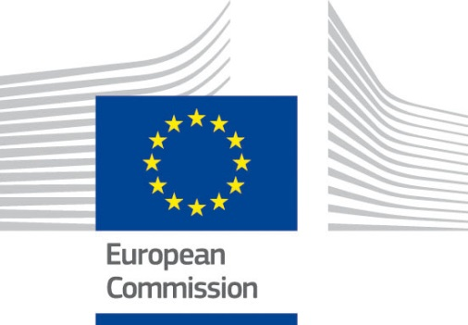

ANNEX C2: Twinning Proposal
between
Member State X, (Member State Y in case of consortium)
and
Beneficiary Administration in Beneficiary country Z

Project title:
Twinning Reference Number: The Twinning Reference Number is in the format "MN 14 IPA TR 01 16" or "AZ 13 ENI JH 02 15"
Publication notice reference:
EU funded project
TWINNING INSTRUMENT

(It is recommended that the complete proposal should not exceed 10 pages, excluding annexes)
1. Basic information
Lead Member State (MS):
Member State body: The institution responsible for the implementation and financial management of the project. Please provide contact details.
Junior Member State(s) (if any):
Member State body(ies) (if any): See above.
Beneficiary administration:
Twinning Sector: e.g.: Justice and Home Affairs
EU funded budget (maximum amount of grant):
Execution period (months):
Proposed Project Leader (PL): Member State, full name and position, institution
Junior Project Leader(s) (if any): Member State, full name and position, institution
Proposed Resident Twinning Adviser (RTA): Full name and position, institution
Proposed Component Leaders: Member State, full name and position, institution

2. Project understanding
Present an assessment of the project and its needs.
Present briefly how you see this project as part of a larger (reform) process and plans for to coordination and cooperation with other actors in the same sector.

3. Structures / institutional framework offered by the Member State(s)

Explain in detail the structures set up in the Member States relevant for the sector and area in question and inform of the capacities – including staff profiles - of these structures and which part(s) of the structures would be involved.
Explain plans to link such structures to the existing Beneficiary country structures and who will focus on what.

4. Results per component
Present your understanding of actions and activities required to achieve each of the foreseen mandatory results/outputs.

5. Proposed methodology

Present briefly your foreseen strategy, methodology and an indicative timetable with targets set for each of the mandatory results/outputs.
Describe the methodology and approach the Member State considers most likely to successfully achieve all mandatory results/outputs and implement the project in a sustainable manner.

6. Proposed activities per component
Exemplify the methodology described above, listing the key activities that are meant to achieve the mandatory results/outputs of the project and to ensure its sustainable implementation.
Address the needs seen for study tour programmes, training programme etc – and indicate if possible the resources required on the side of the Beneficiary administration in order to efficiently and timely implement the project.

7. Comparative advantage of the proposal
Give examples of what conceptual or concrete ideas adding particular value to the proposal e.g. "Working groups will be created for each component under the leadership of component leader counterparts. The planned activities will be implemented by experts from different Member States working together as a team with the staff of the Beneficiary administration"

8. Risk analysis
Present the implementation risks possible to identify up-front, the ideas on how to control/mitigate these, the impact if emerging – al based on the assumptions and taking into account the resource (and/or complementary action) requirements presented in the proposal

Risk | Likelihood of occurring | Impact | Corrective measures/Mitigation | Assumptions

9. Junior MS(s) added value (if any)
Provide as well the name and position of the Junior Project Leader (JPL).
10. Component leaders
Provide the names, positions and profiles (experience, education etc) of the proposed team of experts.
11. Other short-term experts
Provide an overview – not the CVs of – of profiles (experience, education) available in the administration for implementing the activities for each of the mandatory results/outputs.
12. Indicative Budgets
Indicate how your ideas and the proposal translates into the budget – indicating the break down on the three budget headings and under the budget heading for indicative costing of the components linked to mandatory results/outputs – as Annex A3
13. Communication and visibility plans
Present the ideas and concepts you foresee for communication and visibility activities and the scope expected.
14. Sustainability
The achievements of a Twinning project (from results per component to impacts) should be maintained as a permanent asset to the Beneficiary administration even after the end of the Twinning project implementation. This presupposes inter alia that effective mechanisms are put in place by the Beneficiary administration to disseminate and consolidate the results of the project.
As concerns Twinning projects that includes support to development of sector policies (strategies and action plans), development of new legislation or amendments (especially acquis), the sustainability of mandatory results/outputs is best ensured by ensuring that policy and legislative proposals are backed up by at least basic impact assessments (regulatory, fiscal) and they are consulted with both internal and external stakeholders (inter-ministerial and public consultations), as required by Beneficiary country legislation. Sufficient time should be allocated to this preparatory work during the project, and fast-track adoption procedures of legislation should be avoided, because they risk implementation and enforcement of future legislation.
Since results should be sustained the Beneficiary should describe how they in their budget planning (Medium-Term Business Planning (MTBP) or alike) have planned necessary resources ensuring the sustainability.
15. Crosscutting issues (equal opportunity, environment, climate etc…)
Assess how the project objectives contribute(s) to pursing gender and human rights policies as well as eventually tackle equal opportunity, environment, climate change minorities, regional coverage, etc.
16. Implementation start
Indicate the date by when the proposed RTA is available to start his assignment
17. Initiation phase
Inform what your plans are for development of the initial work-plan including involvement of Project Leader(s) and/or Component Leaders and/or other support staff and the intentions regarding involvement of the PL(s) in future work-plan developments and in implementing the communication and visibility plan.

ANNEXES TO PROPOSAL
1. Proposed Logical Framework matrix in standard format (compulsory)
2. Indicative implementation schedule
3. CVs of PL(s), RTA and Component leaders in Europass format
No other CVs should be presented in the proposal

https://europass.cedefop.europa.eu/en/documents/curriculum-vitae

